# ****Provider Portal – 30 Hours Funded Childcare****

## ****Overview****

All children are eligible for 15 hours funding per week from the term following their 3rd birthday. This will be referred to as the Universal Offer / Hours.

Approved families will be able to claim an additional 15 hours per week. This will be referred to as the Extended Offer / Hours.

Eligible families apply directly to HMRC via their website for the Extended Offer: <https://www.childcarechoices.gov.uk/>. Applications are managed and approved by HMRC and any queries regarding the application process should be referred to their Customer Interaction Centre on 0300 123 4097.

Once approved, families will be given an 11 digit code starting 500******** or 114******** (temporary code). They must give this code to their chosen Provider who should run a check in the Provider Portal to ensure the code is eligible and against the correct child. Families will be reminded, by HMRC, at the outset, to reconfirm their eligibility regularly.

Check Status – Eligible means the parents have passed the financial checks, not that the code is Valid for the term, please always check the Eligible from and Eligible to dates.

### ****This is the information you should give to Parents regarding reconfirming their eligibility code:****

* As you are aware, every three months, you are required to reconfirm that you remain eligible for 30 hours. You do this through the HMRC website using the log in you created when you first applied.  If your details have not changed, you only need to tick a box in your childcare service account to confirm your details remain the same – this will then automatically be fed back through to local authority systems.
* You should receive two reminders to reconfirm (4 weeks and 2 weeks before your reconfirmation deadline).  If you miss the reconfirmation deadline, despite the reminders, you will receive a message from HMRC telling you that you are no longer eligible for 30 hours however (where you are already claiming extended hours) you will remain entitled until the end of your current grace period .  If you have not claimed Extended Hours with a provider – you will not be able to start a new claim in the grace period.

Once the Provider has completed the check and the code found to be eligible, additional columns will be added against the child on the Headcount task, allowing the Provider to claim the Extended Hours. If the check is not carried out or approved, the additional columns will not be available and the Provider will only be able to claim the Universal Hours.

**IMPORTANT**: Parents must COMPLETE the application **the term before** they wish to take up the funding. When completing the check against the code, if the Eligible From date is after the start of the current term the Extended Hours funding will not be available until the next term. Please see the following table for confirmation of the dates:

|  |  |  |
| --- | --- | --- |
| Term | Term Dates | Apply By Date |
| Summer | 1st April – 31st August | 31st March |
| Autumn | 1st September – 31st December | 31st August |
| Spring | 1st January – 31st March | 31st December |

All checked children will appear in the Expiration Dashboard where Providers will be able to re-check eligibility at the end of the Grace Period for each child.

Continuing claims for funding can be claimed to the Grace Period End date displayed in the Expiration Dashboard. This will always be the end of the current term or the end of the following term.

If a parent falls into their grace period before the child has started a 30 hours place, they will **not** be entitled to take up the place.  The DfE will not fund any extended hours in this instance.

Please also note these conditions:

* If a child has already taken up a 30 hour place within their validity period at one provider, but has moved to a second provider and attempted to take up a 30 hour place within their grace period the DfE will not fund a place at a second provider.
* If a child has taken up a 30 hour place at a provider, leaves, and then re-joins the same provider in the grace period.  The provider will only be able to fund the place if the break was pre planned and agreed.

This document covers the following topics:

* Running a New Check
* Reviewing Previous Checks
* Reviewing and understanding the Expiration Dashboard
* How to recheck a code
* Claiming Extended Hours on the Headcount

## ****Running a New Check****

On the Provider Portal home page select 30 Hours Funded Childcare | Run a New Check to display the Run a New Check page.

If you have access to more than one provider, you will be asked to select the Provider the child will be attending.

You will then see the following screen:

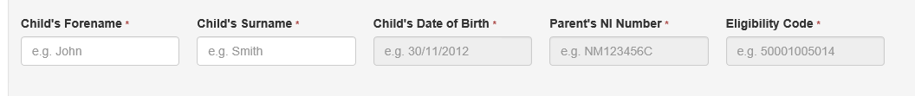

If the child has been added to a previous Headcount task or is already associated with your setting, start to type their name into the Forename field and click on their name when displayed. This will prepopulate the name and date of birth fields.

To run the check, add the Parent’s NI Number and the Eligibility Code and click Run Check. Children that are already on your Headcount list with an eligibility date valid for the current term will now have additional columns for you to add the Extended Hours during the Headcount task.

If the child is not already associated with your setting you will then see the following screen:

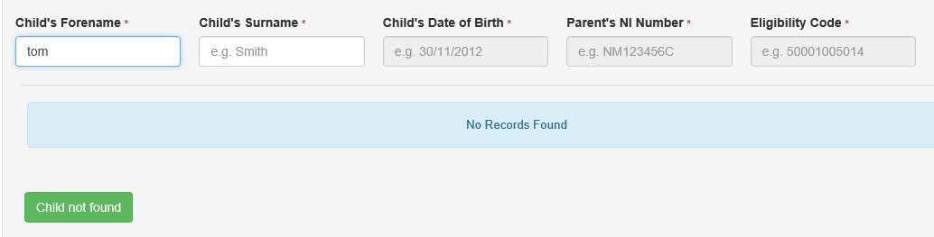

Click on the green button Child not found. Complete all the fields and click Run Check

If the check passes you will see the following message:

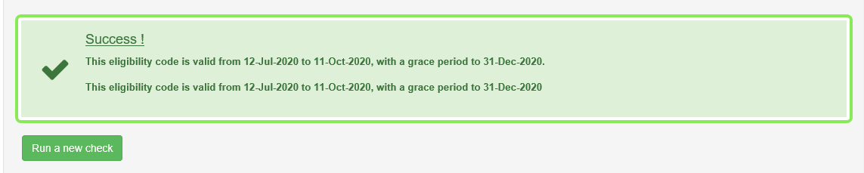

New age 3-4 children will still need to be added to your Headcount list and the code added into the child details then they will also display the additional columns. These children will show as Ad-Hoc Checks in Review Previous Checks.

If the check does not pass you will see the following message:

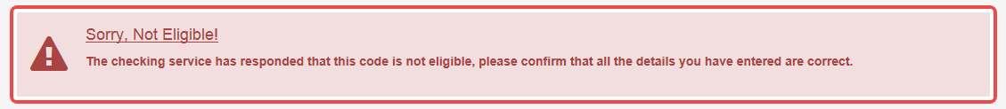

Please confirm with the family that all information they have given you is correct. The check is carried out against the Parent’s NI Number, the Child’s Date of Birth and the Eligibility Code. This must all be correct for the check to pass, including upper and lower case letters

## ****Reviewing Previous Checks****

To review the results of previous checks that have been carried out in the Provider Portal, select 30 Hours Funded Childcare | Review Previous Checks.

Select a Provider from the dropdown list where necessary.

The following screen will be displayed:

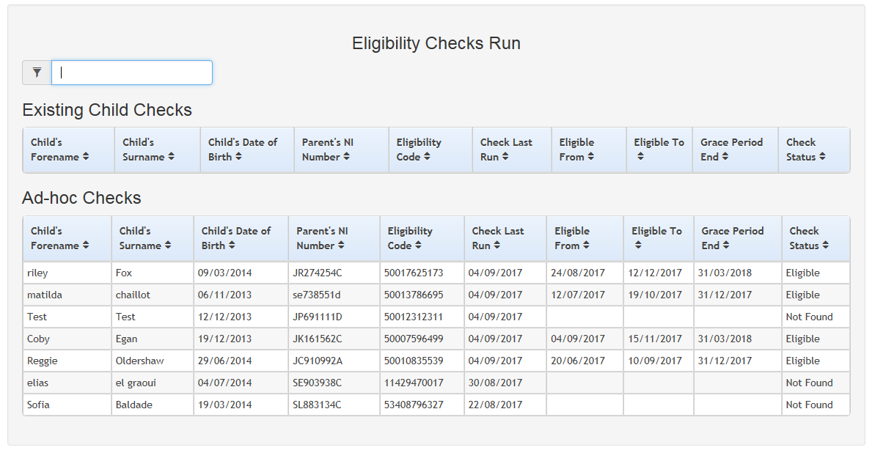

Enter search criteria, such as the child’s name or eligibility code, into the Filter if needed.

The Existing Child Checks panel displays checks for children who are already associated with you – for instance if they have been added to a previous Headcount.

The Ad-hoc Checks panel displays checks for children not already associated with you. **If Ad-hoc checks are run the Eligibility Code will need to be added to the chid details on the headcount task,** or, a further Existing Child Check run once the child has been added to the headcount task.

The most recent checks are at the top of each grid.

## ****Reviewing and Understanding the Expiration Dashboard****

The Expiration Dashboard is used to alert Providers about children who are nearing their eligibility end date and whose parents have not reapplied. The provider can then remind parents to recheck their eligibility in addition to the HMRC reminders that they may also receive.

Colour coding is used to display the number of children whose Eligibility End Date has already expired or will expire within the next 28 days. The number of children falling within each category is displayed on the Expiration Dashboard button on the 30 Hour Entitlement Portal home page as follows:

Expiration Dashboard example.

To view the Expiration Dashboard, select 30 Hours Funded Childcare | Expiration Dashboard.

The Expiration Dashboard initially displays a list of children whose grace period ends in the next 180 days and further action is required, as follows:

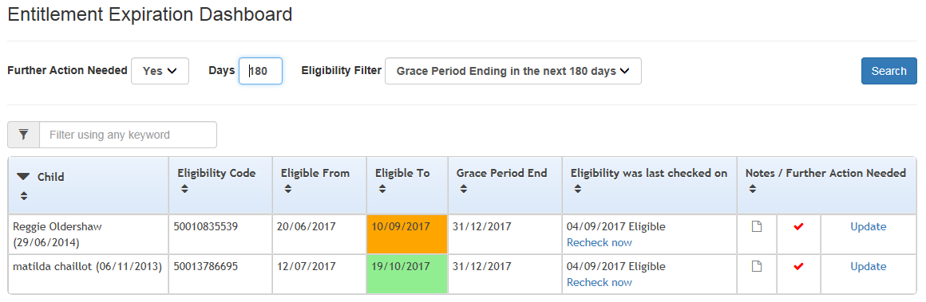

Please note: The Eligible To date is displayed using the following colours:

Red - eligibility has ended.

Amber - eligibility ends in the next 28 days.

Green - eligibility ends in more than 28 days.

You can filter the list of children displayed based on their Eligibility End Date or Grace Period.

The Entitlement Expiration Dashboard will display the following fields:

* Child – The child’s name and date of birth.
* Eligibility Code – The code provided by HMRC to approve the Extended Offer.
* Eligible From – The approval date of the application and start of financial eligibility.
* Eligible To – The date that the family will need to reconfirm their financial eligibility by.
* Grace Period End – The date to which you can claim the Extended Hours for current claims. This may be extended if the parent renews their application with HMRC. Please note that the Grace period will also be the end of a term – a Parent/Provider will never lose funding for Extended Hours during term time.
* Notes / Further Action Needed – Allows you to make notes against a child and update whether further action is needed.

If you wish, you can click the Update link under the Notes / Further Action Needed field to add a note and confirm whether further action is needed:

A screenshot the Notes/Further Action Needed screen



Tick or untick depending on whether further action is needed for this child and add any notes that are required. E.g. if a child leaves you can untick for further action so that they no longer show. Click Save.

## ****How to Recheck a Code****

From the Entitlement Expiration Dashboard you can recheck the code for any children who you have manually checked previously.

You can carry out a recheck whenever you wish however we would suggest always carrying out a check when the Grace Period End date is approaching to ensure you are aware if you can continue to claim the Extended Hours the following term.

To view select 30 Hours Funded Childcare | Expiration Dashboard.



Click the Recheck now link in the ‘Eligibility was last check on’ column against the child you wish to recheck. The following dialogue will be displayed for successful rechecks:

Picture of Eligibility Outcome

Please note: The check displayed on the dashboard is the most recent eligible check for each child and the ‘Is further action needed’ indicator only applies to that check record.

When a recheck is performed, if an ineligible check is returned, this does not affect the Is further action needed indicator. If there is a new eligible check (manual or recheck), the new check record supersedes the old one.

Once the recheck period has finished, the indicator will not change unless there is a manual eligible check.

## ****Claiming Extended Hours on the Headcount****

For the full Headcount and EYPP User guide go to the website [here](https://eycp.essex.gov.uk/funding/data-collection/)

Access the Headcount task by selecting the Headcount tile from the Homepage of the Provider Portal. A list of Tasks will be displayed under My Tasks. Any active tasks will be displayed at the top of the list:

Picture of Task Screen

Click on the active Task to open it.

Any existing children will be displayed and if they have had a successful Extend Hours check carried out against them you will see an EH symbol in the Funding column against their name.

You will see that children with this symbol against them will also have 2 additional columns for completion:

* Extended Hours Claimed per week
* Extended Hours Claimed for term

If a child was previously eligible, but is no longer eligible for 30 hours funding, the Extended Hours columns are greyed out.

Picture of headcount task screen

For any children that have had a successful Extended Hours check completed against them but are not existing children on the headcount, you will need to add the child by clicking on the Add Child button.

Add Child Screen

Enter the child’s details and click the Next button. If a child with this name has had an ad hoc 30 hours eligibility check performed, the details of the existing child are displayed so that their date of birth and eligibility code can be copied across.

Once the child has been added successfully they will appear on the Headcount list with the additional columns available.

**Please note:** Where the funding is being shared between more than one Provider, it is very important for the Parent to confirm how many Universal Hours and how many Extended Hours they are taking at each Provider. You must ensure these hours are added to the correct fields to prevent conflicts.

**IMPORTANT NOTE:** If a check has been carried out against an existing child but the Extended Hours columns have not opened:

1. Click on the child’s name and locate the field titled Eligibility Code.
2. If this field is not populated with the eligibility code, add the code here and save the child record.
   1. If the code is not recognised you will receive a message to advise that a check has not been completed against it. You will need to carry out a 30 hours check in the Portal before proceeding.
3. If the Eligibility Code field is populated and the additional columns are still not open, you will see an Eligibility Date noted against the code. If this date is after the start of the term (see table on page 1), the family will not be eligible until the following term.

Complete the task following the guidance in the Headcount and EYPP User guide, which can be found [here](https://eycp.essex.gov.uk/funding/data-collection/).