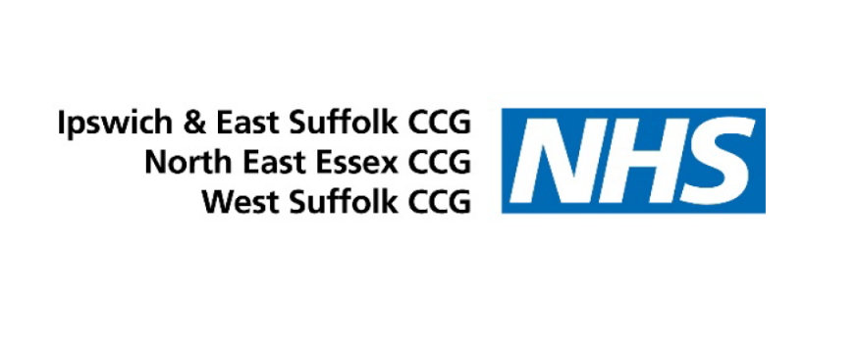

Responding to false and misleading information about the COVID-19 vaccination programme: Advice to Headteachers, Teachers and Parents

Background

Over the past month, some schools and headteachers have received letters or emails which feature false or misleading information (misinformation) about the safety, efficacy and purpose of the COVID-19 vaccination program. There have also been reports of leafleting activity outside of school gates.

What Schools Can Do

False and misleading information (misinformation) about the COVID-19 vaccination programme can be confusing or alarming for staff, children and parents alike, and it can be difficult to know how to respond. Headteachers and teachers are advised:

- Not to engage directly: misinformation narratives and tactics flourish when they are responded to.
- Acknowledge receipt: if a response is needed, simply acknowledge receipt of concerns.
- Reassure: acknowledge the concerns for wellbeing and emphasise and refer to the latest scientific guidance on the issue. Some helpful links include:
  - The WHO Mythbusters Page
  - The Check Before You Share Toolkit

Further Resources

There are a range of resources available to help children and adults understand these issues including:
- BBC Teach: Fake News, Teaching Resources
- Go Viral: Learn about some of the most common strategies used to spread false and misleading information
- Internet Matters: a quiz to spot false information
- BBC Bitesize:How to talk to your kids about fake news
- Ofcom resource page: Combatting COVID-19 Misinformation

For accurate and up to date information on Covid-19 vaccines, visit the NHS website: Coronavirus (COVID-19) - NHS (www.nhs.uk)

