Essex County Council

**Self-update portal guidance**

Contents

Self-update portal login 3

Updating service details 4

Adding a new opening date 6

Updating the availability 10

Updating the age range 10

Updating the capacity details 11

Updating the vacancy details 12

Updating travel details 12

Updating school pickups 13

Adding and updating cost details 15

Updating cost details 16

Updating facilities information 17

## Self-update portal login

Log into the Provider Portal on the [Early Years and Childcare website](https://eycp.essex.gov.uk/funding/).

Important. You must email [earlyyearsdata@essex.gov.uk](mailto:earlyyearsdata@essex.gov.uk) if your Headcount Contact details are changing. You must also let Ofsted know of any changes.

Select the Self Update tile from the Home Page of the [Provider Portal](https://emsonline.essexcc.gov.uk/ProviderPortal_LIVE/).

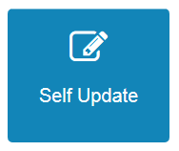

Select the Provider you wish to update from the list provided by clicking on the Provider Name. You will only see one Provider if you only have one setting assigned to your login. If you have more than one setting assigned to your login you will need to select which one you wish to update.

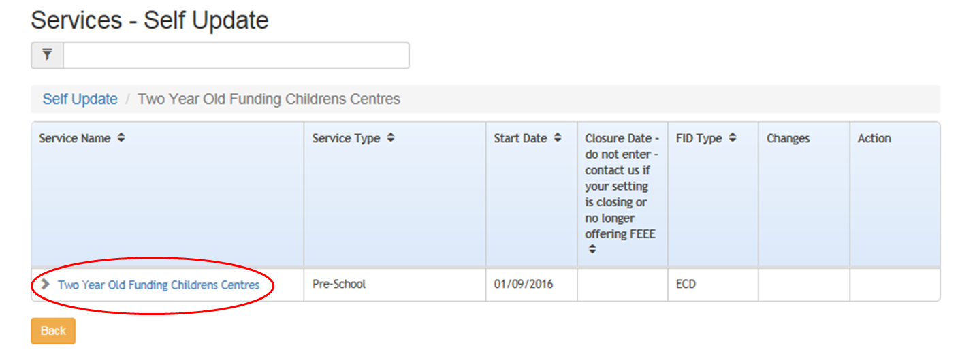

You will see the Service Details tab. You can go to the different tabs to view and update the details. The more you enter the better as it will help parents/carers to see your childcare offer. The other information field is there for you to add details about the childcare you provide. It will go on the family information service website if you give consent.

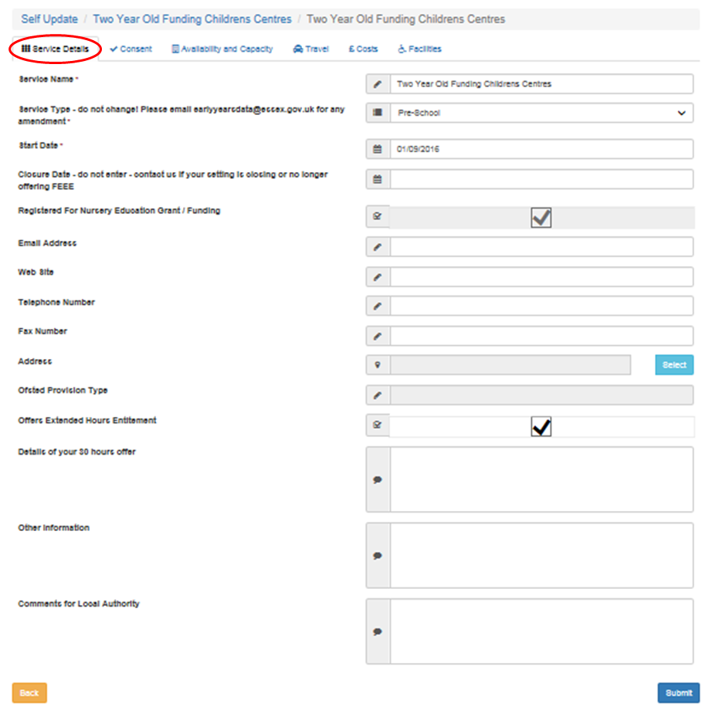

## Updating service details

Important. Do not amend Service Type or ‘Registered for Nursery Education Grant / Funding’ even if your status changes. We (Essex County Council) will manage this at all times.

If your status changes please email: [earlyyearsdata@essex.gov.uk](mailto:EARLYYEARSDATA@ESSEX.GOV.UK)

You can use the Self-Update portal to make changes to the details about your service. After making the changes, submit them to us for approval.

View the Service Details tab. You can make changes to the basic details such as email address, telephone number and address.

Click ‘Submit’.

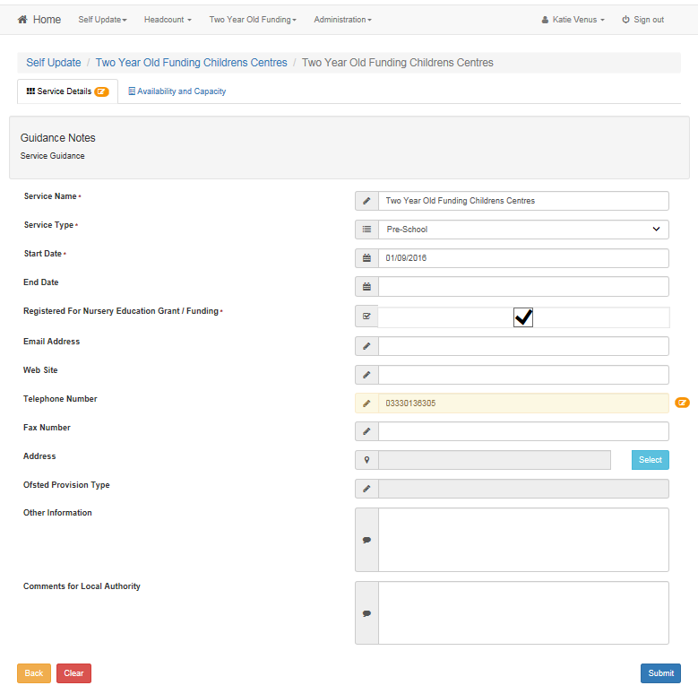

You will now see that the changes have been highlighted. Also the indicator for ‘Pending Changes’ has been applied against the amended fields.

Use the ‘Clear’ button to remove the changes you have made if you need to.

You will receive an email after we review the changes. You will need to log into the Provider Portal to see the saved changes.

Important - You must email [earlyyearsdata@essex.gov.uk](mailto:earlyyearsdata@essex.gov.uk) if your Headcount Contact details change. You must also let Ofsted know of any changes.

Use the consent tab to allow us to share your details and to say how you prefer us to contact you.

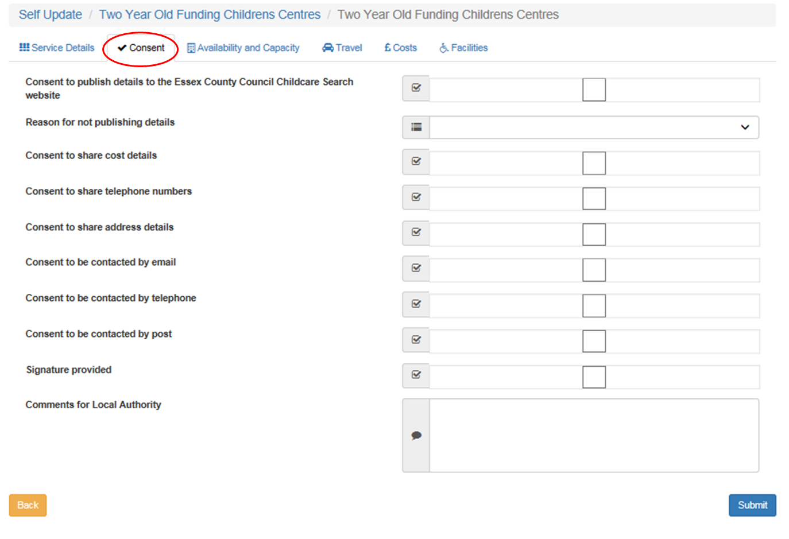

Update your consent details and select ‘submit’.

The Availability and Capacity tab will show you several additional tabs to view and update.

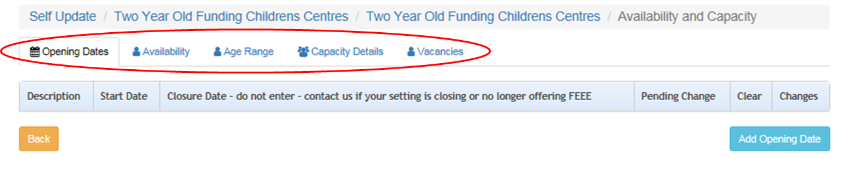

## Adding a new opening date

Select the Availability and Capacity tab, and ensure you are on the Opening Dates section. Click the Add Opening Date button.

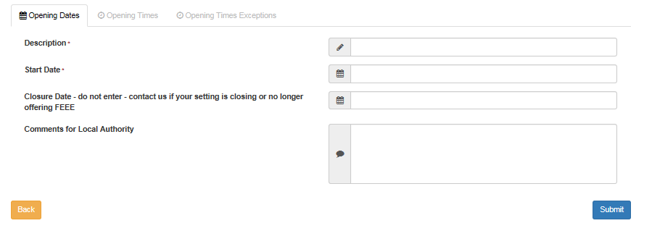

Enter a Description, such as Term Time, and a Start Date.

Do not enter a closure date. Contact [earlyyearsdata@essex.gov.uk](mailto:earlyyearsdata@essex.gov.uk) if your setting is closing or you no longer offer the funded early education entitlement (FEEE).

Enter any relevant comments for Local Authority.

Click the ‘Submit’ button.

You will now be able to add new Opening Times for the Opening Date. To do this, select the Opening Times tab and click the Add Opening Time button.



Add the Weekday, Start Time and End Time and complete any additional fields that you wish to. Click ‘Submit’.

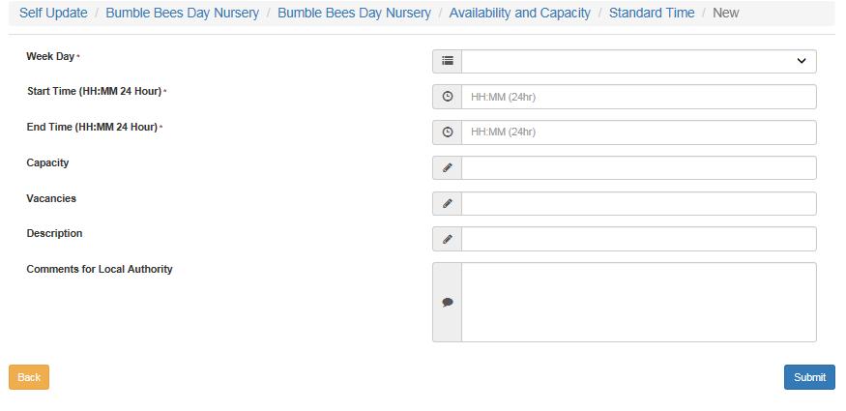

You will need to repeat this action for each day of the week that you are open.

You will see that the changes have been highlighted. Also the indicator for ‘Pending Changes’ has been applied against the amended fields.

clear screen

Use the ‘Clear’ button to remove the changes you have made if you need to.

If required, you can now add exceptions to the opening times for this opening date.

Select the Opening Times Exceptions tab.

Click on the ‘Add Opening Time Exception’ button.

Exceptions could include for example:

* polling day or,
* school has requested the setting to close for a period of time due to construction work.

add opening time

Complete the fields for the required exceptions and click the ‘Submit’ button. The amended fields will be highlighted. Also the indicator for ‘Pending Changes’ has been applied against them.

amend and submit

If you wish to update the existing Opening Dates click on the name under the Description column.

opening times

You will then be able to amend any fields in the Opening Dates, Opening Times and Opening Times Exceptions tabs. Then click ‘Submit’.

## Updating the availability

From the Availability and Capacity menu select the Availability tab. Enter the required information and click ‘Submit’.

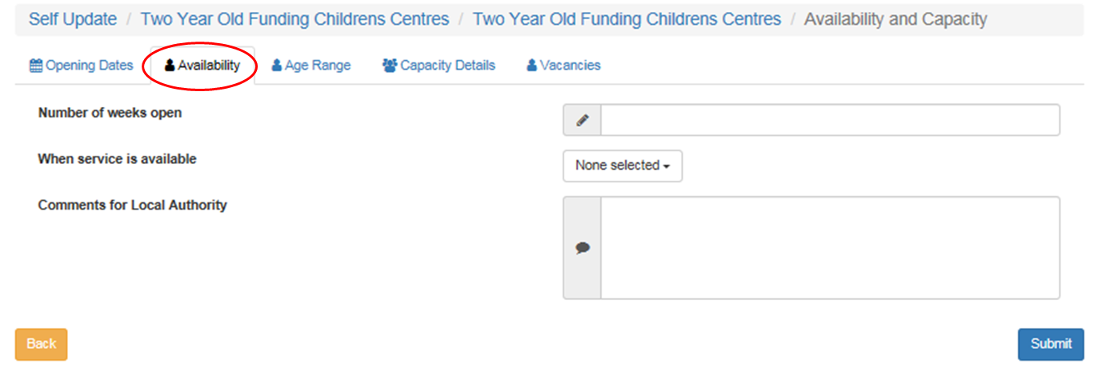

## Updating the age range

Click on the Availability and Capacity tab and then the Age Range tab.

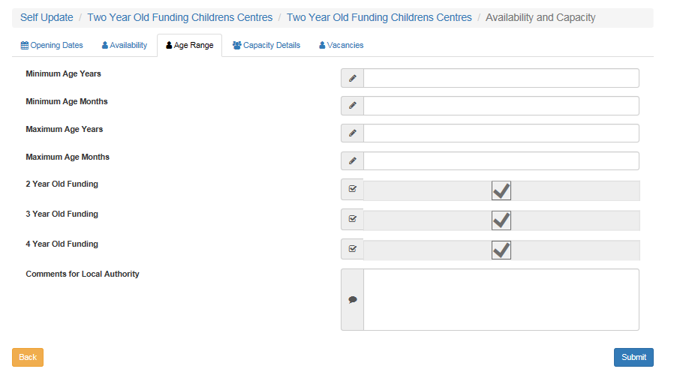

Complete the required fields, ticking / unticking the relevant ages that you offer funding to. Click Submit.

## Updating the capacity details

To update the information about capacity, vacancies and waiting list for the provision click on the Availability and Capacity tab from the Home Page. Then click on the Capacity Details tab.

You can add capacity, vacancies and waiting list details for age ranges you choose. Select the ‘Add Age Range’ button to add.

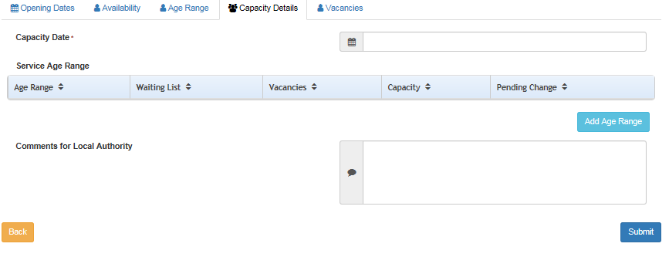

Select an age range from the drop-down menu and add the numbers for Waiting List, Vacancies and Capacity.

Example of adding age range below

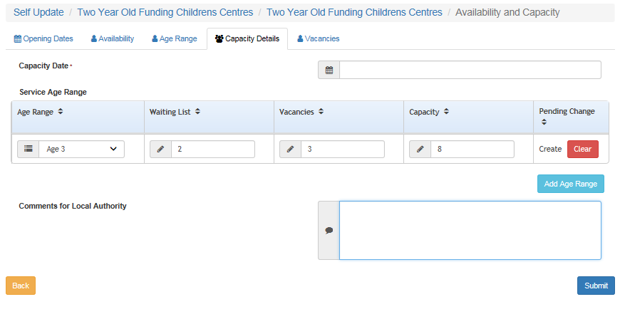

Select submit when finished.

We suggest that you update this data at least once a term.

## Updating the vacancy details

To update the information about vacancies, including contacting the service about vacancies and whether the service has a waiting list, select the Vacancies tab from the Availability and Capacity home page.

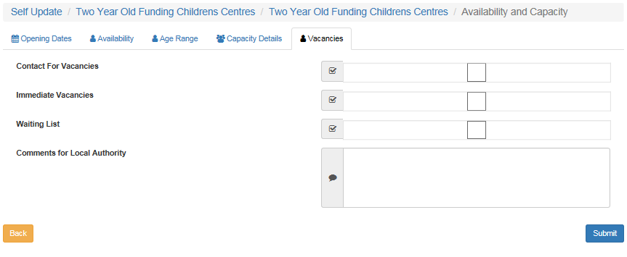

If required, select or deselect the check boxes and enter comments. Click the Submit button.

## Updating travel details

Select the Travel tab to update

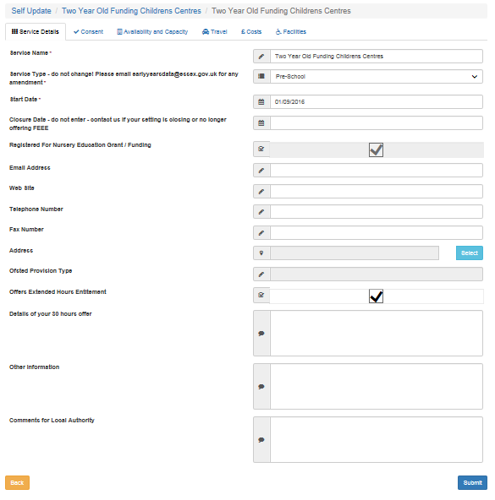

Tick fields for parking space and own transport if applicable. Then enter any other information regarding transport that parents / carers may wish to know in the Travel Information field.

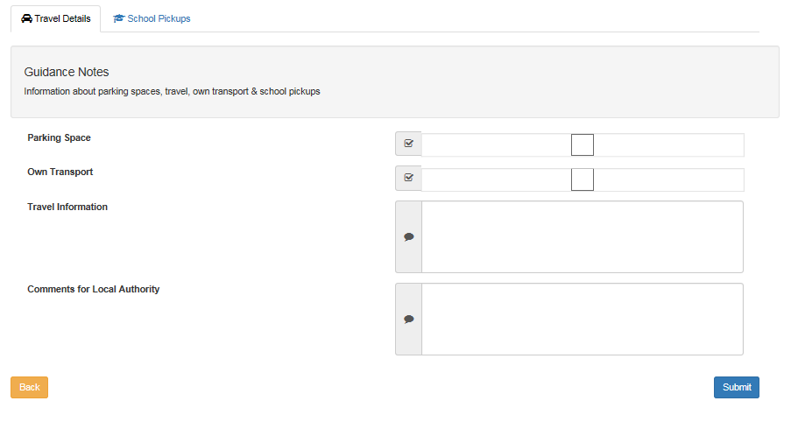

Enter transport Info here

Select submit when finished.

## Updating school pickups

From the Travel home page – select the School Pickups tab



Select Add School Pickup to enter a school or setting that you pick-up from.

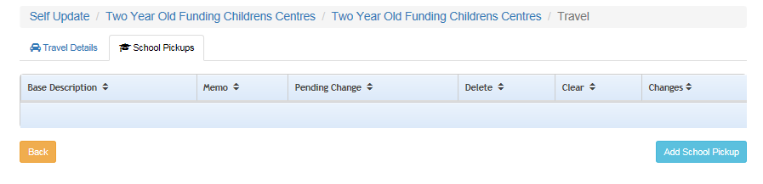

Choose the Select button to find the school / establishment you require.

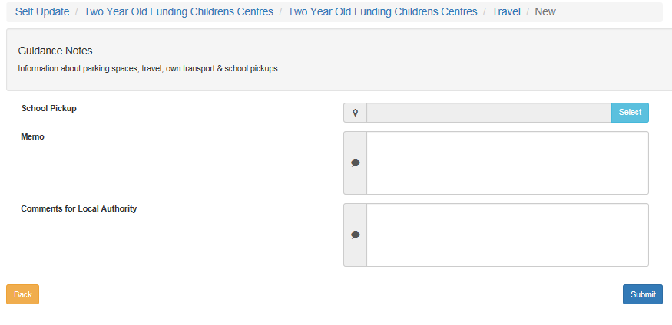

A search window will open allowing you to search by name / type of provision

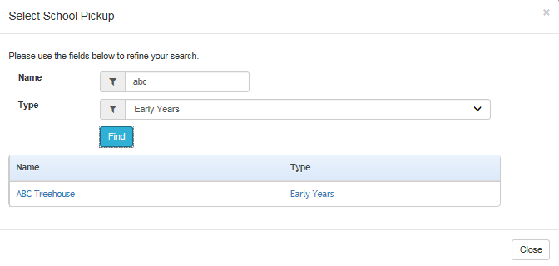

Select the provision/school required

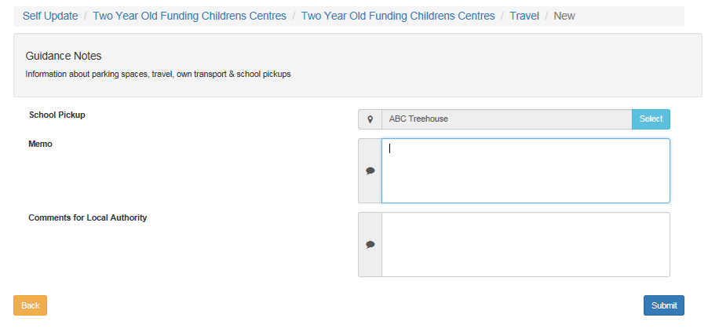

Enter any notes in the Memo field.

Repeat the process for any other school / setting pickups you wish to add.

## Adding and updating cost details

Select the costs tab from the provision home page



Select the ‘Add Charge Details’ button

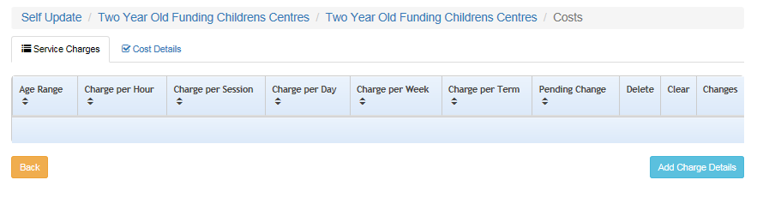

Update the details as required, then select submit.

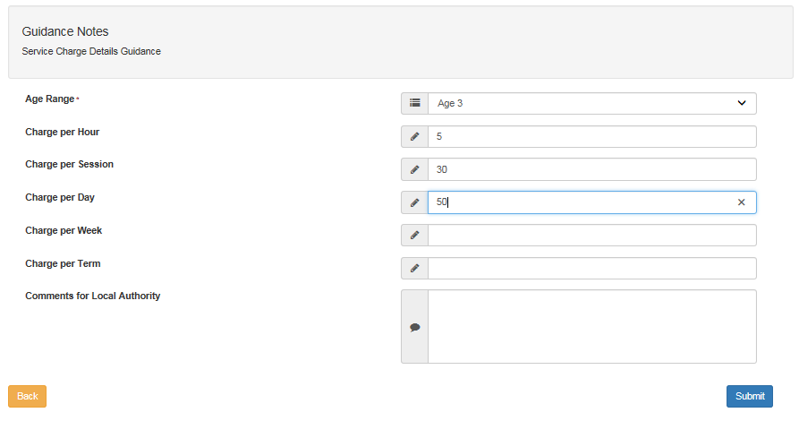

Repeat the process as required for other age ranges.

We suggest that you update this data at least once a term.

## Updating cost details

Select the Cost Details tab, and tick Sibling Discount field if required. Enter any notes for Local Authority and select submit when finished.

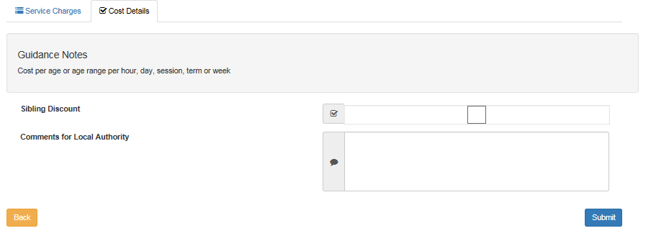

## Updating facilities information

Select the Facilities tab from the provision home page.



Update the information as required. Select submit when finished.

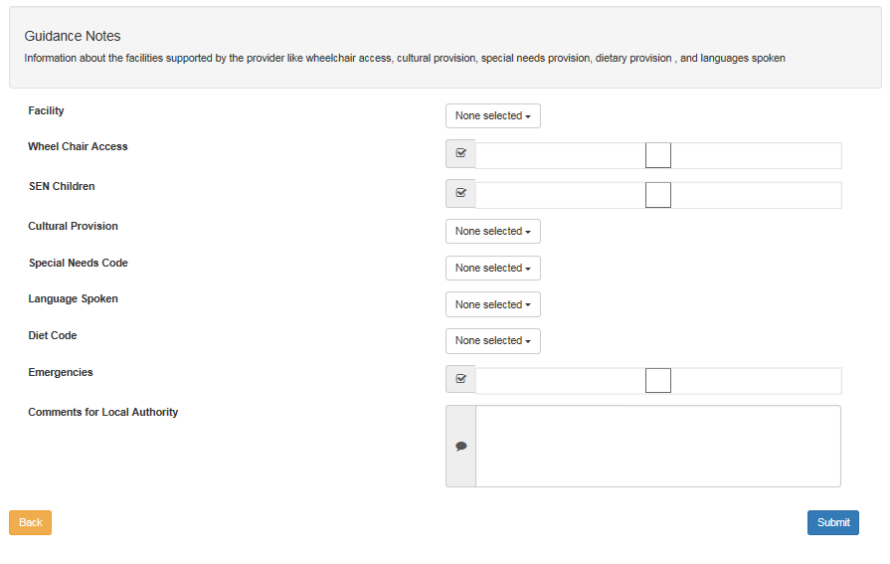

Thank you for reading this guidance.