Better Start
  - Frequently Asked Questions
Please review the following frequently asked questions prior to raising your query.

Q. Do I need to make a submission if I do not have any funded 2-year-olds this term?
A. No. If you have no funded 2-year-olds, the task does not need to be submitted. Please note, you will be unable to submit a blank Better Start task, so if you do not have any funded 2-year-olds, the task can just be ignored.

Q. When does the Better Start task need to be submitted?
A. Each term the Better Start task will be opened at the same time as the Amendment Headcount. We recommend you complete your Headcount submission first, ensuring all 2-year-old funded children are added via the Placement Notification process, and then complete your Better Start task. Collection dates can be found here.

Q. How do I view my Better Start data?
A. Log into the Provider Portal, select the Better Start drop down and then Provider Home. You will see an option on the right-hand side for My Reports.

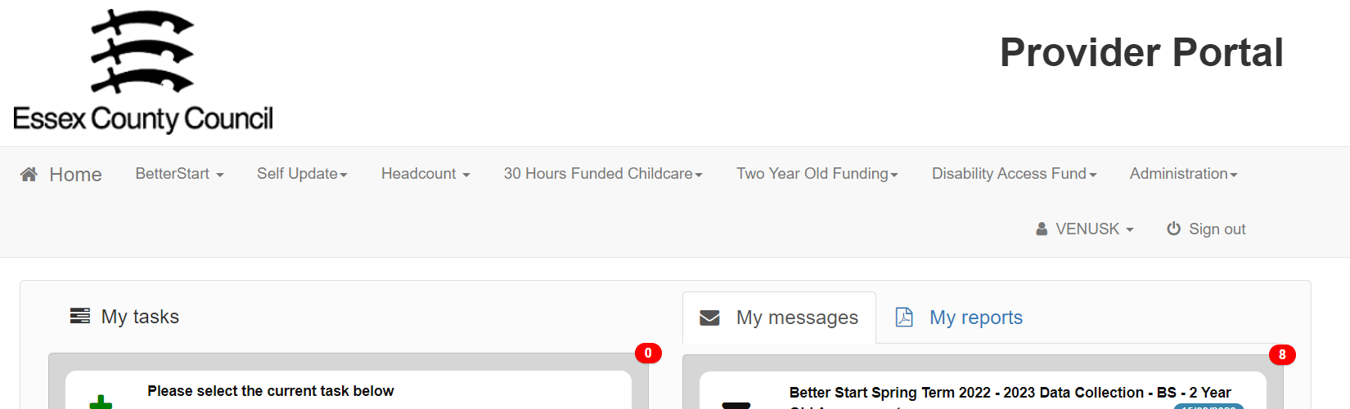
Click on the Run a Report button and select the required report from the dropdown menu and click Next. The report will be created, and you will be given the option to download it.

Q. I cannot log into the Provider Portal. Who do I contact?
A. In the first instance please use the Forgotten your Password? or Forgotten your Username? links on the login screen of the Provider Portal. If your account has been locked, please email 2yearold@essex.gov.uk for assistance.

Q. Can I include non-funded 2-year-olds in my Better Start submission?
A. Although you can add non-funded 2-year-olds to your Better Start task using the Add Child button, please be aware that will add the children against your setting, and they will then appear on your Headcount task. As they are non-funded, you will need to ensure funded hours are not submitted against these children on the Headcount.

Q. I need assistance completing an assessment for one or more of the children. Who can assist me?
A. If you require any guidance on how to complete your 2-year-old progress checks, please contact the Early Years Education team for your area:
South: Eyadviser.South@essex.gov.uk
West: EYFS.West@essex.gov.uk
North-East: eyanortheast@essex.gov.uk
Mid: EYAdvisers.Mid@essex.gov.uk

Q. A funded 2-year-old has joined me late in the term. Do you still need to complete a submission for them?
A. Yes. Please submit your initial assessment for the term they have joined. You will be able to update this data the following term if needed.

Q. A funded 2-year-old has joined me late in the term. Do I still need to complete a submission for them?
A. Yes. Please submit your initial assessment during the term that the child joins. You will be able to update this submission the following term if needed.

