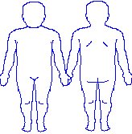

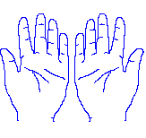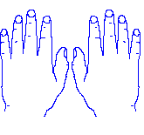

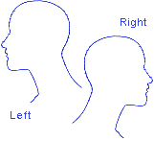

Colour Key

|  |  |
| --- | --- |
| Black | Bruising |
| Green | Swelling and inflammation |
| Red | Burns |
| Yellow | Cuts & or grazes |
| Pink | Marks (anything else) |
| Blue | Pain |