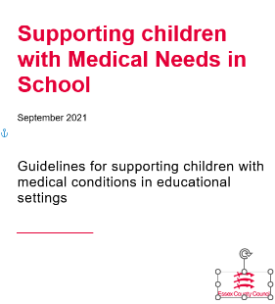

Supporting children with Medical Needs in Early Years Settings

September 2021

Guidelines for supporting children with medical conditions in educational settings.
This template is designed to support settings to be able to develop a care plan for children with medical needs. It is a check list of what we would expect to see in a care plan and should be developed alongside the above document available to download from the following link which includes further information on risk assessments and roles and responsibilities.
https://schools.essex.gov.uk/Pages/Search-Results.aspx?k=Supporting%20children%20with%20Medical%20Needs%20in%20School%20%20September%202021%20Guidelines%20for%20supporting%20children%20with%20medical%20conditions%20in%20educational%20settings.

The Healthcare Plan should include:
- the medical condition, triggers, signs, symptoms and treatments
- the pupil’s needs and the impact on the child, including:

  - details of any medication needed storage and disposals of medication, dose and method of administration
  - clinical procedures that need to be carried out, by whom, when and how
  - any tests that need to be undertaken and action to be taken depending on the results e.g., diabetes care
- what training is required and how this will be provided
  - description of what constitutes an emergency and what action should be taken and information required
  - written permission from parents that the medication can be administered either by a member of staff or self-administered by the pupil
  - facilities
  - equipment
  - plans that need to be put in place for setting trips and any other activities
  - access to food and drink where this is used to manage their condition,
  - dietary requirements
  - environmental issues, e.g.,
  - support for the pupil’s educational, social and emotional needs

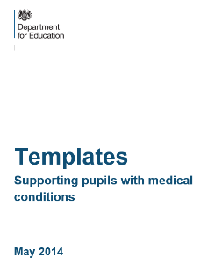
Templates Supporting children with Medical Conditions (May 2014: Department of Education) can be download from the link below. The templates can be adapted and used within your setting and the document includes the following.
Template A: individual healthcare plan
Template B: parental agreement for setting to administer medicine.
Template C: record of medicine administered to an individual child.
Template D: record of medicine administered to all children.
Template E: staff training record-administration of medicines.
Template F: contacting emergency services.
Template G: model letter inviting parents to contribute to individual healthcare plan development.
https://assets.publishing.service.gov.uk/government/uploads/system/uploads/attachment_data/file/349437/Supporting_pupils_with_medical_conditions_-_templates.docx

Template A: individual healthcare plan - example downloaded and adapted.
Name of setting
Child’s name
Room e.g., 0-2’s preschool or room name
Date of birth
Child’s address
Medical diagnosis or condition
Date
Review date (this could be reviewed along with your one planning)
Family Contact Information
Name
Phone no. (work)
(home)
(mobile)
Name
Relationship to child
Phone no. (work)
(home)
(mobile)
Clinic/Hospital Contact
Name
Phone no.
G.P.
Name
Phone no.

Who is responsible for providing support in the setting

Describe medical needs and give details of child’s symptoms, triggers, signs, treatments, facilities, equipment or devices, environmental issues etc.

Name of medication, dose, method of administration, when to be taken, side effects, contra-indications, administered by/self-administered with/without supervision.

Daily care requirements (what does this look like in practice)

Specific support for the pupil’s educational, social, and emotional needs

Arrangements for setting visits/trips etc.

Other information

Describe what constitutes an emergency, and the action to take if this occurs.

Who is responsible in an emergency (state if different for off-site activities)

Plan developed with (names of parents/carers and professionals involved)

Staff training needed/undertaken – who, what, when

Form copied to and parental signature.

Learning and Development

What is the impact of the child’s medical condition on their learning and development? Please describe what this looks like in practice.

What provision have you implemented through your High-Quality Practice, Reasonable Adjustments or Ordinarily Available.

Has a one plan been implemented to support this child? If so, please attach making sure it sets out the graduated approach.

Yes ☐
No ☐

If you have not started a one plan, please explain the reason below.

