**ONLINE FORMS: S23**

1. Open Section 23 Notification of a child under compulsory school age following the link - <https://essex-self.test.achieveservice.com/service/Section_23_Notification_of_a_child_under_compulsory_school_age>
2. Read the information on the front induction page then click next
3. This is where all the information will be submitted, there are 2 tick boxes that first appear, both of them must be agreed to process

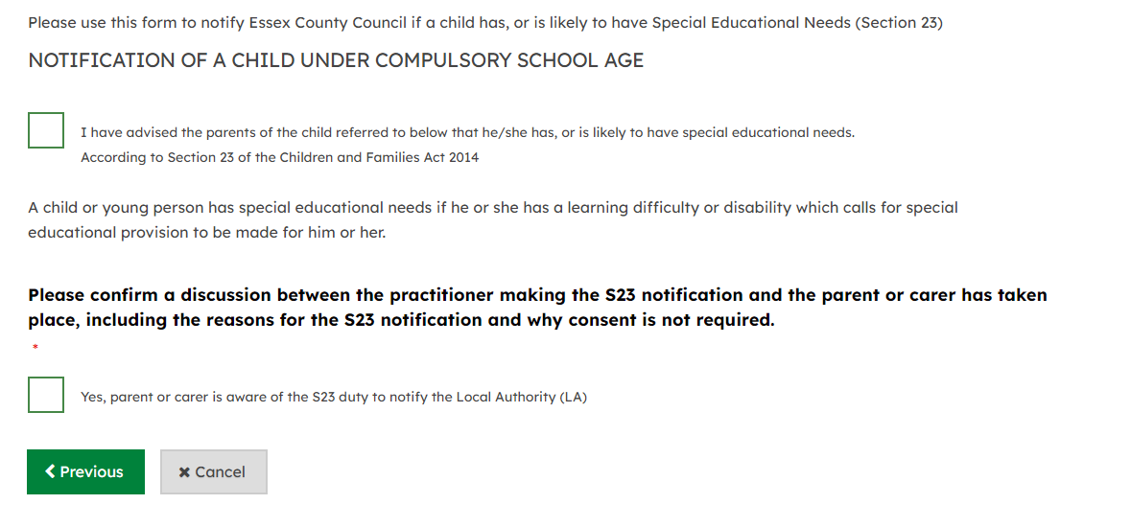

1. Once both boxes ticked, the rest of the boxes will appear below
2. Start with the child’s detail, including their name, date of birth, address and NHS Number –
3. use the postcode search and then select the correct address or enter the address manually

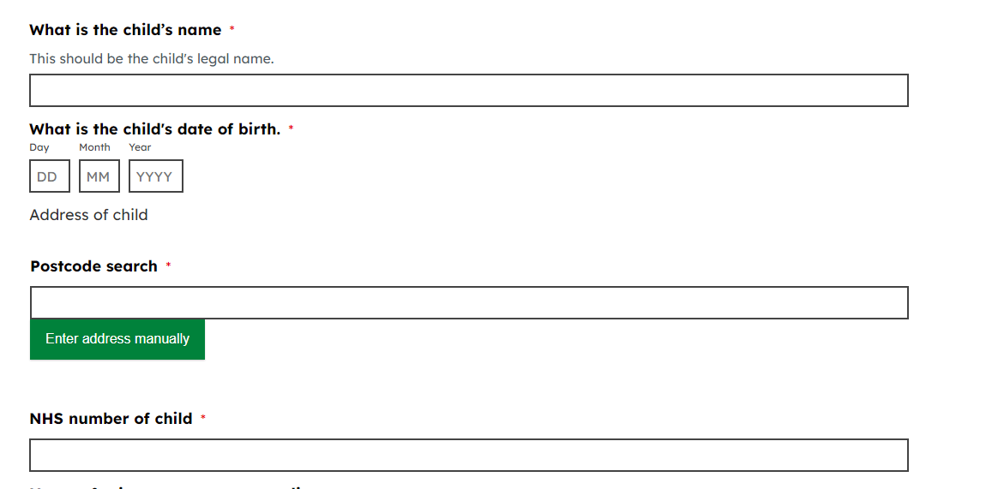

1. Next there will be questions relating to the child parent/guardian, please fill these out including there name, relationship to child, address and contact details

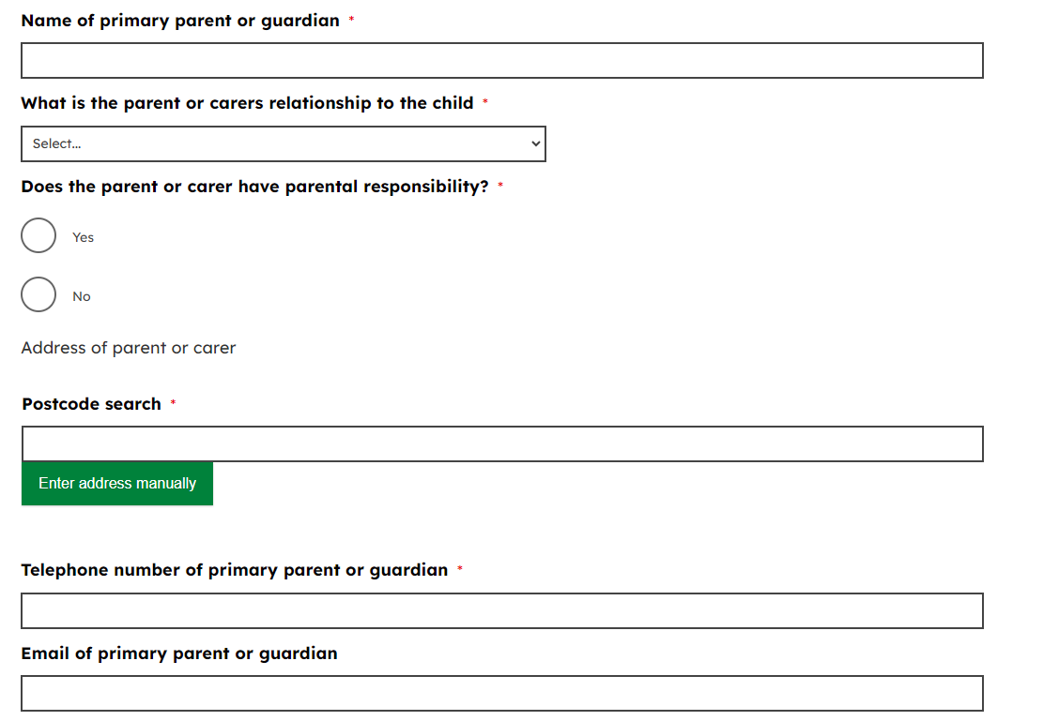

1. Below the primary parent/guardian details is all the secondary parent, please enter their name and contact details if they are known
2. The next questions asks if the child is attends a early years setting.
   1. **If NO**, please move on to the child’s area of need question
   2. **If YES**, please provide the name of the setting and ender their postcode to find the address if it is known

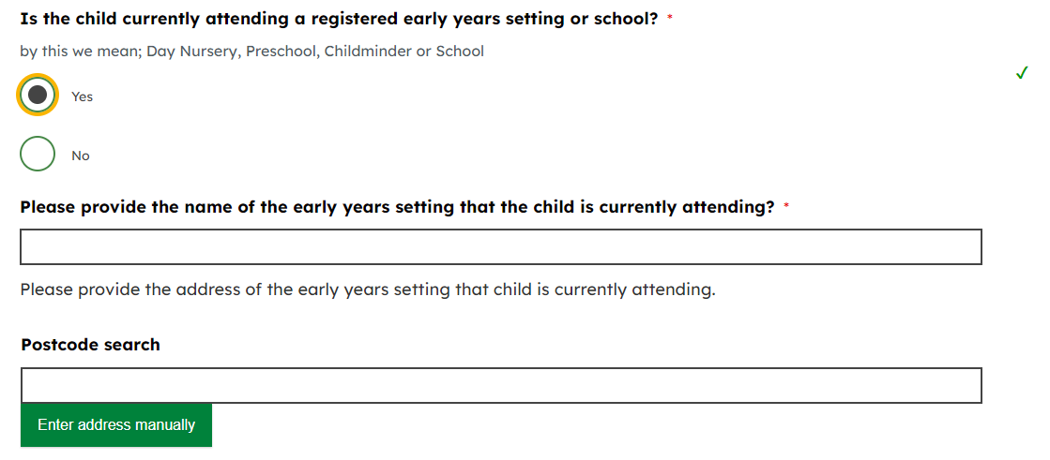

1. Select one of the area of needs from the list provided. Please refer to the below descriptors to help decide which area of need is most applicable:
   1. **Communication and Interaction**
      1. The child experiences difficulty communicating with others. This may be due to speech or comprehension difficulties, or where they do not understand or use social rules, eg where autism is a possible diagnosis.
   2. **Cognition and Learning**
      1. Where a child may learn at a slower pace than their peers, even with appropriate differentiation. The range for this area of need is broad – from moderate learning difficulty through to profound and multiple learning difficulties where there is a complex need as well as a physical disability or sensory impairment.
   3. **Social, emotional and mental health**
      1. A child may appear withdrawn or isolated or display challenging behaviours. This may reflect underlying mental health difficulties such as anxiety, depression or self-harm. Possible diagnoses related to SEMH include ADD, ADHD or attachment disorder.
   4. **Sensory (a difficulty involving one of the senses) and/or physical needs**
      1. Where a child has a disability that prevents them accessing general education facilities. There may be a physical/neurological need, or the child may have a hearing/vision impairment. This category should NOT be used for a child engaging in sensory seeking behaviour.
2. If ‘Communication & Interaction’ is selected or ‘Sensory /Physical / Medical’ please also then choose one of the other options from the list that appears

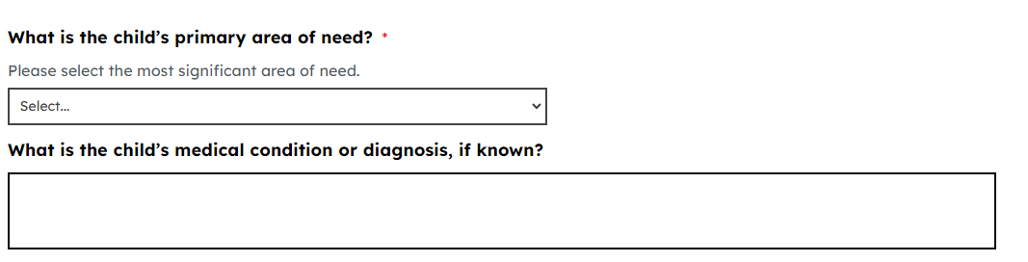

1. You will then be asked to provide some evidence, you must provide one the options given but both may be provided if you wish.
2. If you choose to write a summary you must provide full detail about the child’s needs, what the child’s needs look like in practice and how this may impact their access to education.

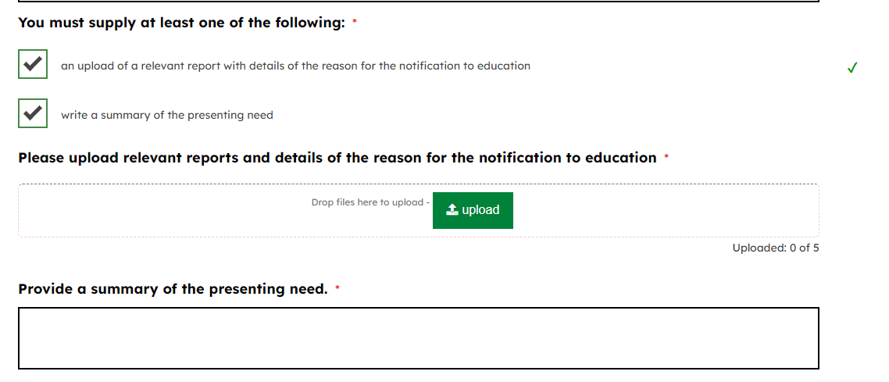

1. The last section is questions relating to the person who has initiated the S23 and the person submitting the form if it is different. Note that the person who has initiated or authorised the S23 should be band 7 or above.
2. There is also a box to provide additional comments if you wish to do
3. Once the form is completed you can submit, this will take you to a summary page of what has been submitted, ***an automatic email with the submissions is no longer sent, if you would like to keep the answers submitted please you can download the PDF***
4. If you have an account, the completed form will be found in the My Submitted Requests tab at the top of the page and will appear as below

