**ONLINE FROM: SENIF**

1. Click the link to open the SENIF Application Form
2. To submit an application for SENIF, please create an account – you will not be able to submit an application without an account
   1. Select sign up to create an account and enter an email and password, wait for link to confirm sign up and then log in

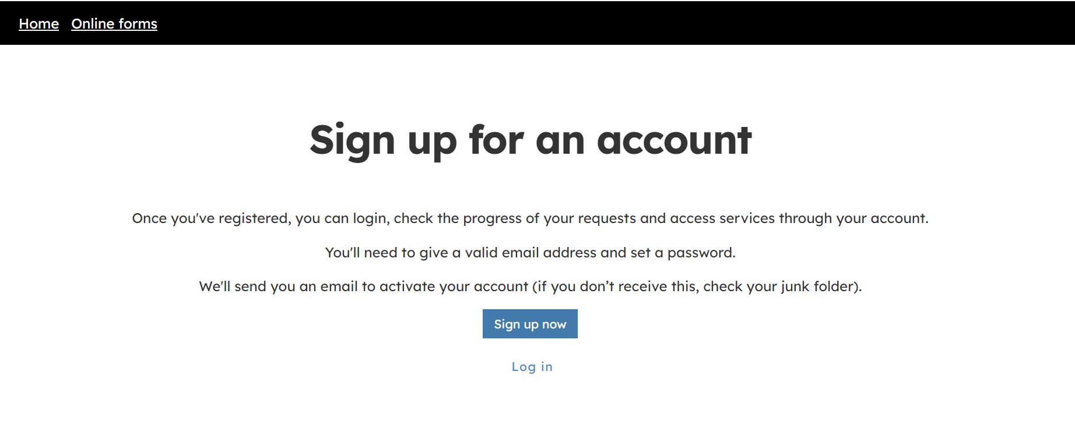

* 1. Once logged in for the first time you will be asked to create a profile to complete the set up, this will only need to be done once

1. You will start on the introduction page, where there is some information to read through about the SENIF Funding process.
   1. At the bottom of the page is a tick box to confirm that parents have been informed about the details of their child being shared with ECC – you cannot proceed without agreeing to this

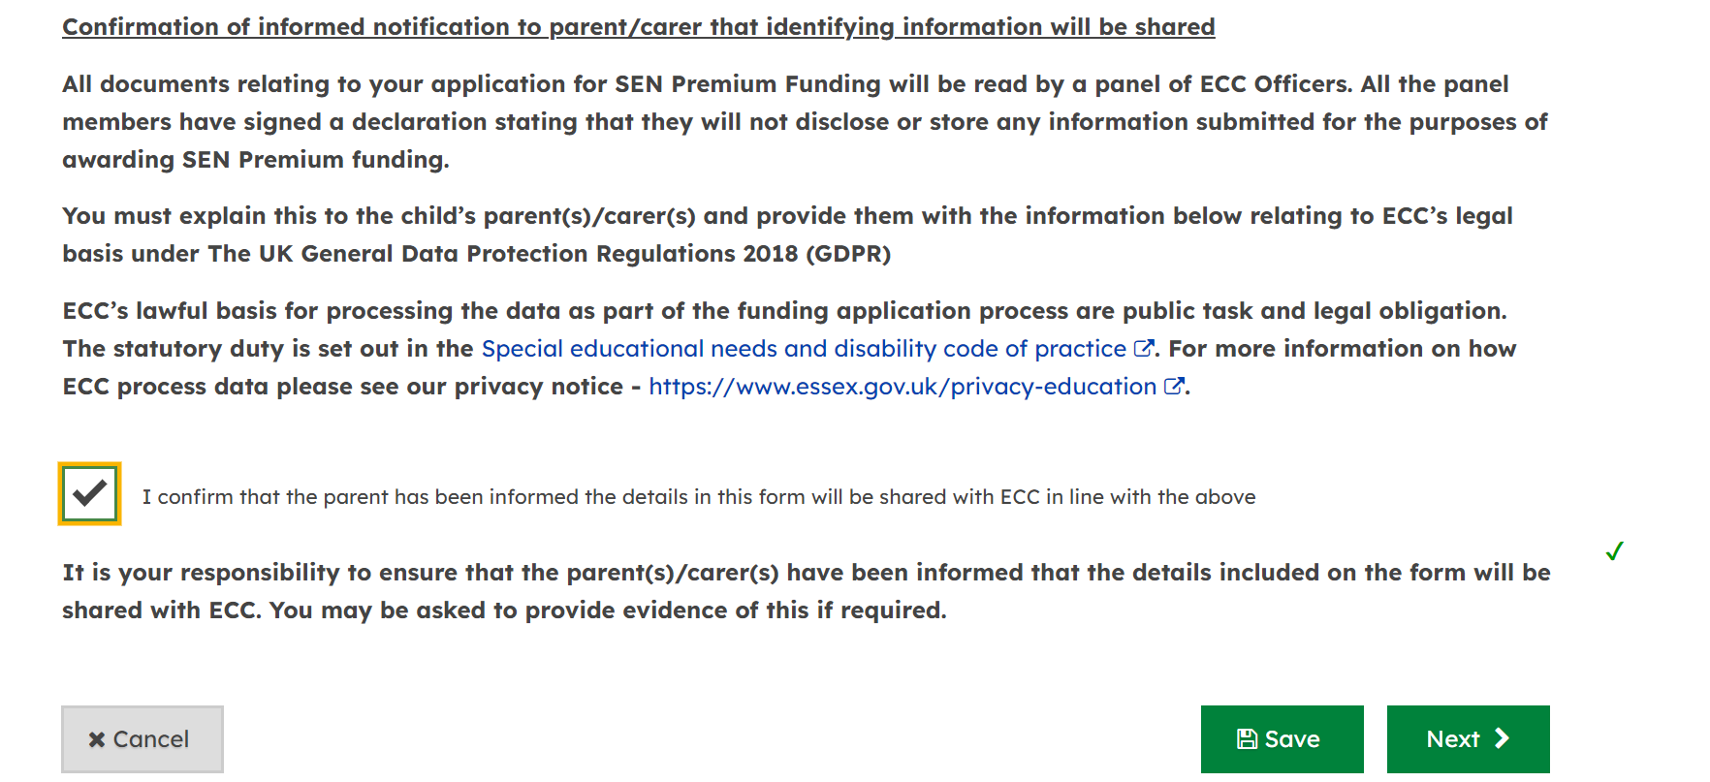

1. Once you have ticked the confirmation box, select next and this will take you to the next section ‘About the Child’. Fill in the below details. Please note that questions marked with a red star are compulsory.
   1. Name of child
   2. Their address - look up their postcode and then select the address from the drop down or type in manually
   3. Date of birth (you can type manually or select from the calendar)

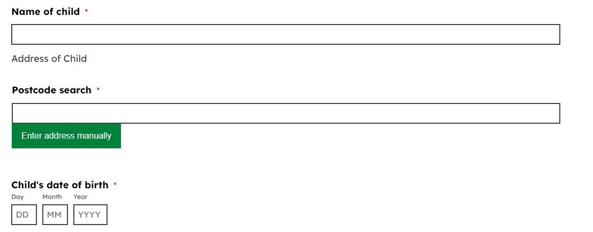

* 1. When the child started attending the setting
  2. Date they are due to start school, if this is known
  3. Date of current review of one plan
  4. Date of previous review

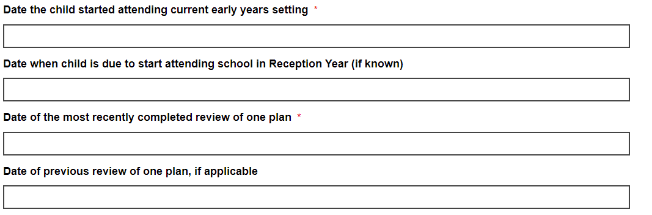

* 1. Upload the one plan
  2. Upload any additional supporting documents you would like panel to see

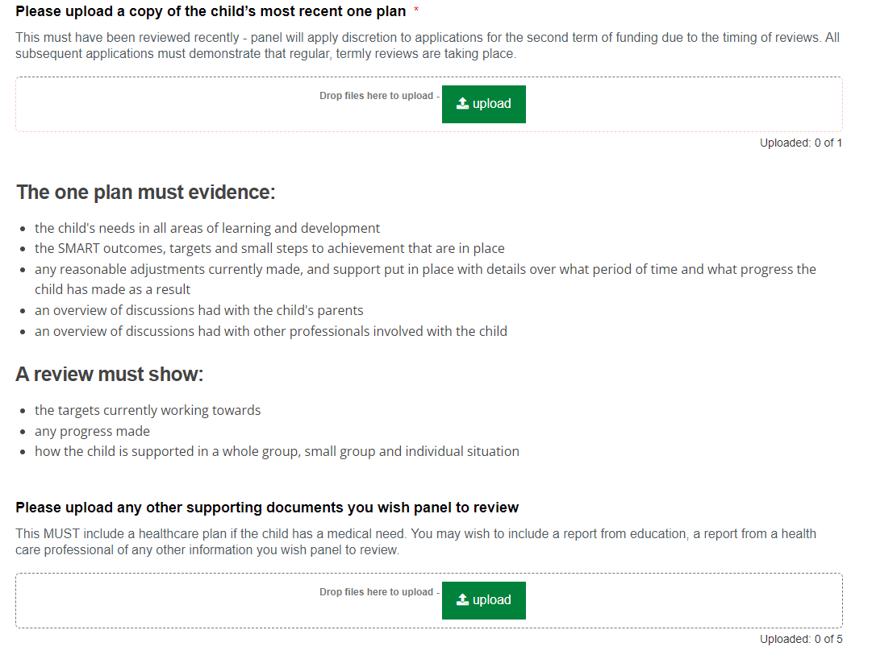

* 1. Select if your setting (not the child) has a current Essex County Council FEEE funding contract
  2. Input the total number of FEEE funding the child claims for the funding term at the named setting
  3. Tick yes or no if a PAF for the FEEE hours for this child has been completed

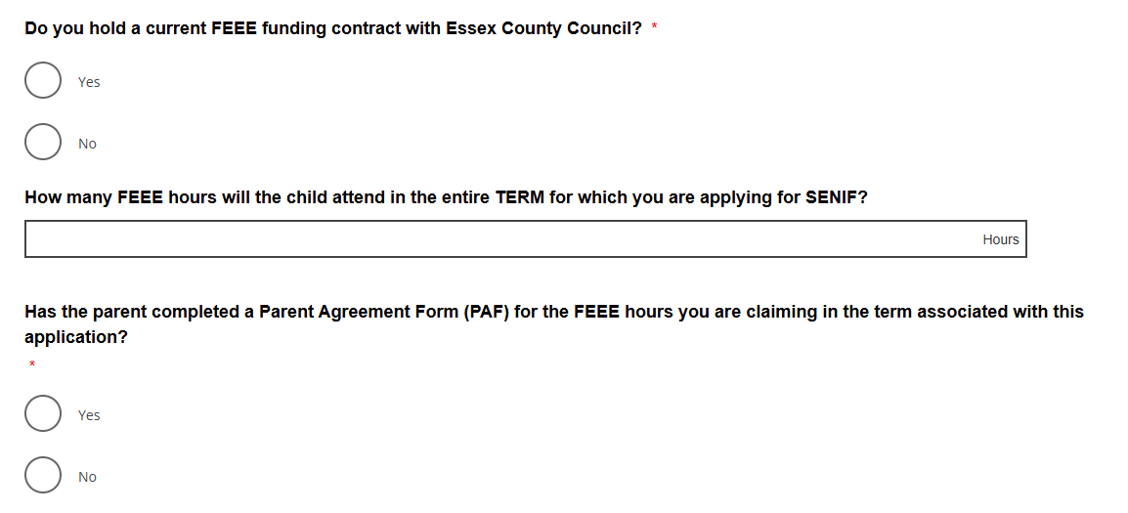

* 1. Input the actual hours attended (panel will consider funding applications for their actual hours of attendance when banded medium or high.)
     1. **Please note we can fund for a maximum of 10 hours a day**
     2. **When a child does not attend on a specific day please input 0**
  2. Enter the actual number of weeks the child attends. If this is different to the term time 38 weeks or the full time 51 weeks, please select other and a text box will appear to enter the hours.
  3. Select one option for the main area of need, there is a description of each category of need for reference if you are not sure.

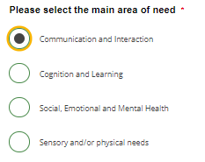

* 1. Please select if the child is on a diagnostic assessment pathway list
     1. If YES, you will be asked to supply evidence in the form of a document, if you cannot do this please enter no and include that the child is on a diagnostic assessment pathway in the additional comments

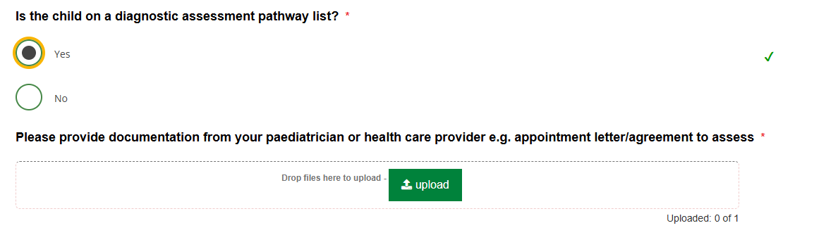

* 1. 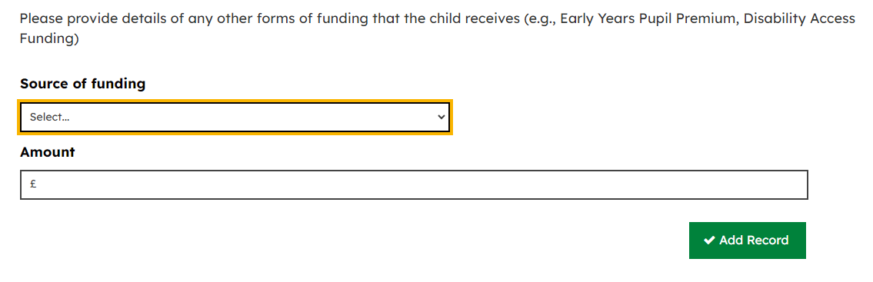Provide details of any other funding the child receives, if they do so, by selecting the source of funding, entering the amount and then clicking ‘Add Record’

1. Once you click next, this will take you to the next section ‘About the request for Funding’
   1. Select the term which you are applying for – please note that the submission windows on our website <https://eycp.essex.gov.uk/funding/funding-to-support-inclusion/early-years-resource-panel-meeting-dates/>
   2. Choose the type of request**, if you have selected new or ongoing** please chose which term of funding you are applying for – only one term of funding can be applied for at a time

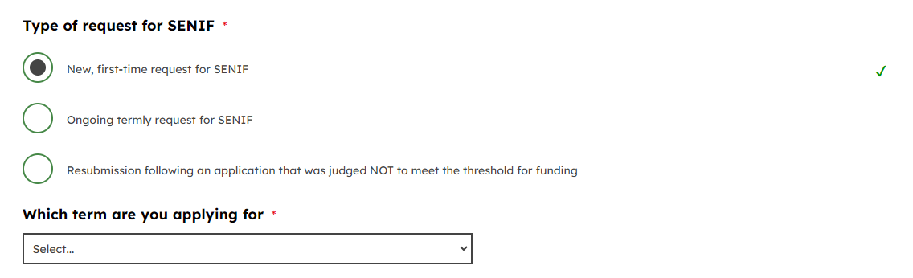

* 1. **If it is a resubmission**, further questions will apply. Select if all the actions requested by panel have been carried out and provide detail on the actions taken or the updates made and then select the term
  2. If SENIF has previously been agreed and funded for, please select **ongoing termly request for SENIF.** Further questions will appear regarding our monitoring of the previous SENIF funding

1. The next section is about the about the setting
   1. Start with the details of the person who is submitting the request and the contact details for the setting. Use the postcode search to find the setting’s address and select the right one from the drop down or type the address in manually

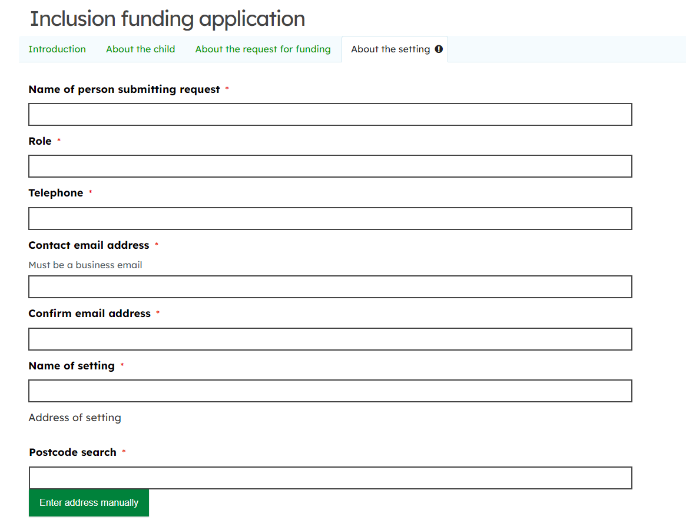

* 1. The final stage is to put any notes or comments you think the panel should know. Use this field if you would like panel to consider a rate increase, to provide any information not already included that is relevant or to note if the child attends another setting in addition to yours

1. Press the submit button at the end and this will take you to the summary page of your submission.
   1. It will detail the reference number
   2. A copy of your answers
   3. It will also ask if you would like to download a pdf copy of your submission at the bottom of the page. You will be emailed a copy of your submission, including supporting documents.
   4. Click continue to take you to the My Submission Requests homepage

**MY SUBMITTED REQUESTS**

* At the top of the online form page is the tab ‘My Submitted Requests’, this is where you’re your applications will go
* Once that have been submitted will appear as below, by clicking on the application you will be able to see the summary which shows the name of the child and term that is being applied for.



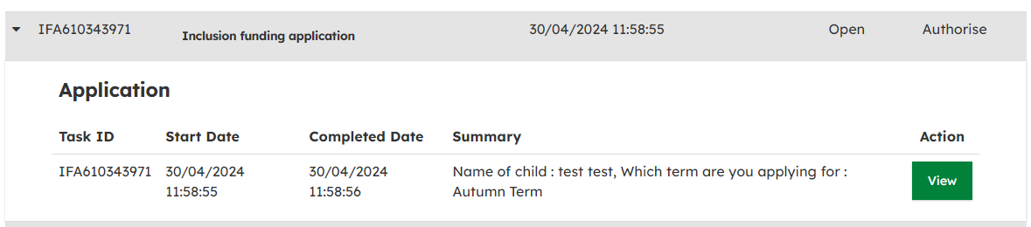

* At any point during the form, you can also save and come back to it later. When filling out the form at the bottom will be a green save button, once you click this you can exit the screen and come back to your submitted requests to finish the form

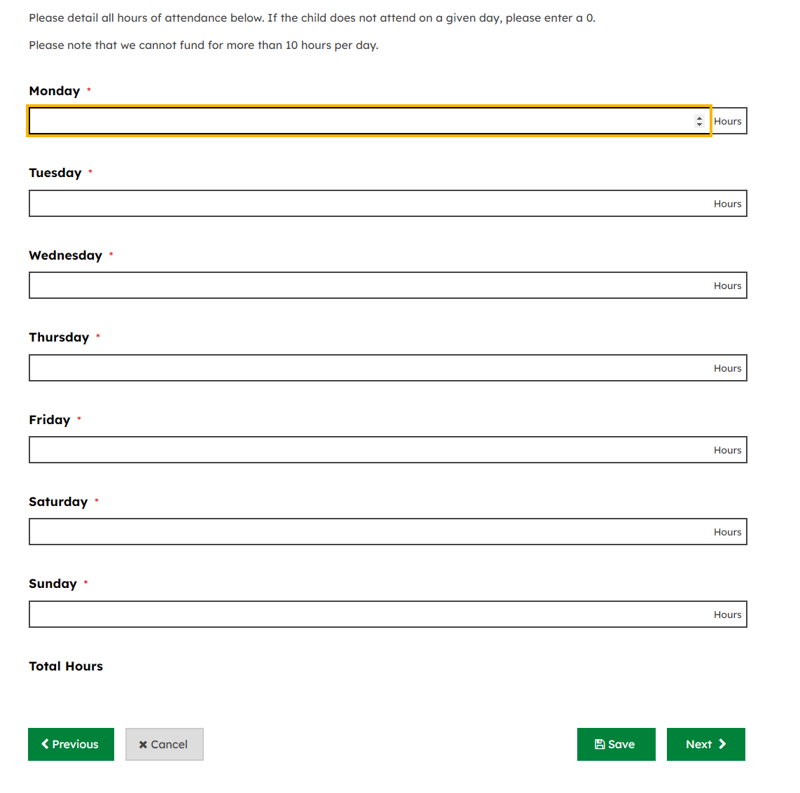

* Saved applications that have not been submitted will appear as below. By clicking in to the box, there will be a green button that says continue which will take you back to where you were in the application - **PLEASE NOTE SAVED APPLICATIONS WILL BE DELETED AFTER 30 DAYS**

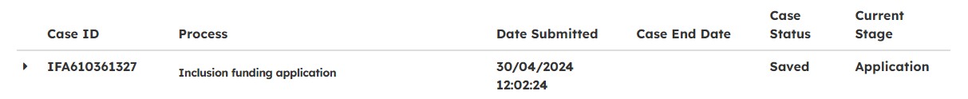

* When the application is accepted the case will be closed and the current stage will say case closed



* When the application is rejected the case will be closed



* When the application needs additional information, it will appear with the white background in ‘my submitted requests’ as below.



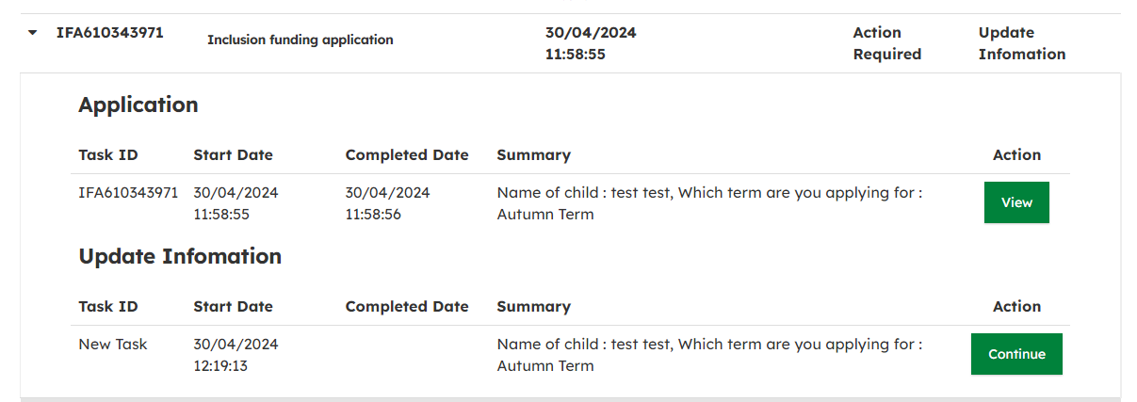

* To view the update, click continue and you will be taken to the application and at the top will say what the action is, review the information and then submit at the end

