Essex County Council
Checklist For Early Years Construction/Building Projects
May 2025

Summary

  - This checklist acts to assist and to ensure Health and Safety, Building Regulations, Planning legislation and other aspects of any building project have been well thought out and that all necessary Statutory obligations have been satisfied and all statutory approvals have been achieved.
  - It remains the Early Years responsibility to seek and appoint appropriate professional advice when developing and implementing their proposals.

- Employing a Property Consultant (intended for projects over £75k value)

  - For all building or maintenance projects that involve the employment of a contractor or sub-contractors, Early Years Providers should always employ the services of an appropriately experienced and qualified professional property consultant such as an Architect or Chartered Building Surveyor (preferably members of professional bodies such as RICS or RIBA).
  - The advice of a consultant should also be obtained in the case of projects carried out by staff or volunteers. This is essential if the work involves demolition or other disturbance of the existing structure.

- Building Regulations

  - Early Years Providers must consider the need for a Building Regulations application in respect of the work, and the timing that is required to achieve approval.
  - The Local Authority Building Control department should be consulted for all projects.
  - Your appointed designers should be aware that the Department for Education Construction Standards will apply to your project and must be considered for all projects. Any works at the Early Years must not commence until the full plan's submission has been approved.
- Health & Safety / CDM Regulations

  - The Construction, Design & Management (CDM) Regulations 2015 is the legislation that applies to the entire duration of the construction process, on all construction projects, from start (early concept) to finish (in use).
  - The CDM Regulations require you to make suitable arrangements for managing a project, through the design, delivery and completion and in use. This includes making sure duty holders are appointed at the appropriate time and with the appropriate level of resources to manage the project. You will need to make sure all relevant information is prepared and provided to other duty holders, and you will need to appoint the appropriate principal designer and principal contractor and ensure they carry out their duties within the CDM Regulations.
  - Health and Safety law places duties on you as employers and your contractors/workers to consider their own safety and that of others. The principal law is the ‘Health and Safety at Work Act 1974’, with The Construction Design and Management Regulations 2015 (CDM15) relating directly to the Act. Clients (this means Schools), Principal Designers, Principal Contractors, Designers and the Self Employed each have responsibilities as duty holders for Health and Safety, some overlap, while others are specific to a particular group. Any individual or organisation that wishes to remain compliant with the law and avoid punitive measures and sanctions should visit the following website: https://www.hse.gov.uk/construction/index.htm. Schools should note that, if an organisation does not comply with CDM, or an individual within that organisation is identified as wilfully breaching any regulation, such parties should expect to be investigated and if the case is strong enough, will be prosecuted. There are large fines and prison sentences for anyone who breaches the CDM regulations.
  - The Health and Safety Executive (HSE) must be notified (This is an F10 Notification) of any projects which will:
    - Last longer than 30 days and have more than 20 workers, working simultaneously; Or
    - Exceeds 500 person days.

  - A Health and Safety File must be available on completion and then kept on the premises for future reference. Your consultant will advise you further on these regulations and advice is available via the HSE website. It should be kept and updated for the life of the building.
  - Early Years providers can access and use the ECC Policies, however, this service is provided at a cost, If you wish to buy into the ECC Health and Safety Advisory service they should contact the Corporate Health and Safety Service via HS@essex.gov.uk. Or 0333 013 9818​​
  - Early Years Providers should consult their property adviser and consider the following Health and Safety risks which may affect staff/pupils/clients/visitors during building works and post completion when the project is in use:
    - Fire evacuation procedures and if the works will obstruct an existing fire escape
    - Early Years start, finish and breaktimes.
    - Contractor access and delivery arrangements/restrictions segregated and hours of work.
    - Arrangements for the storage and transport of materials and waste.
    - Contractor’s risks and what precautions does the contractor intend to take
    - Objects falling from heights,
    - scaffolds (install and removal),
    - ladders,
    - LPG cylinders,
    - tools and plant being left unattended,
    - electrical leads passing through occupied areas,
    - excavations,
    - dust or fumes.
    - Asbestos Risks
  - CDM Regulations ensure you to consider the impact the project works will have on the future maintenance of the building. The design of the building or extension should ensure that maintenance by staff and contractors is low risk, safe, straightforward and as economical as possible.
  - Servicing in the first year will only be picked up by the contractor providing the installation if it is part of your tender documentation or part of their offer. Otherwise you will need to ensure that equipment is serviced/maintained in accordance with the manufacturer’s requirements for your warranties to remain valid.
  - Your contractor should provide you with servicing/maintenance/testing requirements for all work (including detailing your statutory maintenance requirements). You must also ensure that all statutory maintenance/servicing/testing is undertaken.
- Asbestos

  - You need to be aware if the work may potentially disturb asbestos within the property. You need to ensure contractors are made aware of ANY potential asbestos and they must be given access to the Asbestos register.
  - The asbestos register held at the premises will be a starting point, but as it was produced as a result of a visual ‘non-intrusive’ ‘management’ survey (previously known as a ‘type 2’ survey), this will not identify any hidden asbestos and an ‘intrusive’ Refurbishment & Demolition survey (previously known as a ‘type 3 survey’) may be necessary and should be commissioned to match the scope of works being proposed. It is a legal requirement to bring any information you have about asbestos to the attention of the consultant and contractors.
  - You should seek professional advice if any work may disturb the asbestos or if you are not completely sure that your project will not disturb asbestos.
  - Your project may require an intrusive asbestos survey to be carried out before you start work. ECC policy states that only licenced asbestos contractors are permitted to carry out work involving asbestos.
  - If any part of the project is to be completed in a building which was built before 2000 you must consider the risk of disturbing asbestos. Although 2000 was not the last date that asbestos was still being produced in construction materials, if you are unsure how old the building is always er on the side of caution and consider that there is asbestos present until surveys can provide otherwise.
- Passive Fire Safety Policy

  - Early Years providers are strongly encouraged to adopt ECC’s Passive Fire Safety Policy as part of the Design process early in the concept stage. This policy document entitled “HSP 10.3 Passive Fire Safety Policy”.
  - Passive Fire Safety Policy encourages:
    - fire doors to be supplied as fire door sets (proprietary tested) and be from manufacturers that have relevant third -party accreditation for manufacturing quality.
    - fire doors and fire stopping shall only be installed by either a third-party accredited company or a trained individual who has been assessed as competent through third party accreditation.
    - All passive fire protection measures shall be labelled, photographed, scheduled and recorded on plans upon completion by the third-party installer. This is so that the contractor and client have a comprehensive record and audit trail to demonstrate compliance. This will then allow the end user to manage and update during the building’s life.

- Planning Permission

  - You must consider if Planning Permission is required for the work, your appointed professional property consultant should advise you if the Scope of the Project has implications on Local Planning Regulations, and the timing that is required to achieve Planning, as this may impact your ability to start the works. Early Years projects must not start on site until the required planning permission is satisfied.
  - Planning Regulations can be lengthy and complicated, in particular if the proposed works are within a ‘listed’ Building, in a conservation area, or a flood risk area.
  - Pre-application discussions with the Local Planning Authority are encouraged to discuss the particular planning considerations and requirements specific to your property, prior to finalising any proposed works or costs.
  - Early Years providers planning applications will need to be made to the Local City, Borough or District Council.
  - Planning decisions made by the Local Planning Authority, including any ‘Conditions’ attached to the approvals are legally binding.
  - Early Years Providers must ensure that any pre-commencement Conditions that have been appended to the planning application are discharged prior to starting on site.
  - Once a scheme has achieved Local Planning Authority approval, any changes (however minor) to the scheme shall require additional approval. In most cases, a new separate application may be required, which may impact the timing of your project’s delivery.
  - If development is carried out that does not accord with the approved scheme or any of the conditions of the planning permission, the Local Planning Authority can consider taking enforcement action. This could expose an Early Years provider to a requirement to take action to remedy the breach and would also be a breach of Landlord’s Consent, where applicable. Early Years Providers are therefore requested to take particular care in projects where Planning Permission is required. If there are any queries about your Planning Permission, Early Years Providers are advised to contact the relevant City, Borough or District Planning Department for guidance.

- The Equality Act 2010 & Disabilities in Design

  - You must consider the implications of the Equality Act 2010 which imposes a duty on everyone not to disadvantage, or discriminate against, others when it comes to new and maintenance projects. ‘Disability’ is just one of the ‘protected characteristics’ identified in the legislation, and Early Years buildings and their surroundings should be designed to meet the needs of all pupils, staff and visitors equally.
  - Your project and your property consultant should consult all appropriate guidance on the design of Early Years for those with disabilities, including relevant Department for Education Building Bulletins, the Early Years Premises Regulations and BS8300 ‘Design of buildings and their approaches to meet the needs of disabled people’. Other than facilities being designed to meet the physical needs of people with disabilities, it must also be remembered that appropriate selection of materials, finishes and colours should be used to assist those with other forms of disability, such as visual and audio impairment.

- Insurance
  - Early Years Providers must inform their insurers of the scope of works, the programme detail and the value of the project to ensure the works and buildings are insured throughout the project duration.

- Landscape/Ecological Issues
  - To ensure the local Legislation is adhered to, Ecological Surveys by a suitably qualified Ecologist should be undertaken prior to commencing design or development.
  - For more details please contact the Council’s Ecology Team at Place Services (email ecology.placeservices@essex.gov.uk) who can provide further guidance and, where appropriate, arrange surveys and any necessary mitigation measures.
  - As part of the design process, Early Years Providers must consider if the project works will affect trees or hedges both inside and outside the Early Years boundary. Some trees may be covered by a Tree Preservation Order or are in a conservation area, therefore consent for the work will be required from the local Planning Authority. In some cases, hedges can be covered by the Hedgerow Regulations 1997 and their preservation should be considered as part of the design of the project.
  - The Wildlife and Countryside Act, the Sea Fisheries (Wildlife Conservation) Act and the Wild Mammals (Protection) provides statutory protection for certain species of animals and plants. All new building, refurbishment and maintenance projects need to comply with this legislation. Legally Protected Species include many that are widely distributed in Essex and likely to be located within the grounds or buildings such as, breeding birds, reptiles, badgers, great crested newts and bats.
  - Any project or work that could potentially impact protected species needs to be completed in accordance with the appropriate legislation and may require a licence from Natural England. Undertaking work without a valid licence can result in a fine of up to £5,000 or six months in prison per offence.
- Water services

  - Should your project be making changes to the incoming water supplies, you must notify the Local statutory water company. The Local statutory water company has the authority to inspect existing services and, if defects are found with works completed by your project, which could result in contamination of main supply or waste of water Local statutory water company will insist that repairs are carried out.
- Public entertainment licences

  - If any part of the building is licensed for public entertainment, approval from the District Council’s Licensing Officer may be required before work starts on site. The legislation and regulations for the licence should be considered as part of the design in the early stage.

- Completion Certificates

  - In the case of Properties which lease the site from Essex County Council, Early Years must submit drawings of the proposed works to Essex County Council and for record purposes following completion of the works. Drawings of the completed works should be sent to Lambert Smith Hampton, Greenwood House, 91-99 New London Road, Chelmsford, Essex CM2 0PP for the attention of David Stancombe. Electronic format plans should be issued as .pdf and can be emailed to dstancombe@lsh.co.uk.
  - For all works that involve alterations electrical and/or mechanical services these must be tested by a competent sub-contractor on completion, and you must ensure that all testing and completion certificates are issued by the subcontractor and held on file within the H&S Operation and Maintenance Manual on completion.

- Delivering the works on site things to consider:

  - Ensure there is a Pre-Contract meeting by the property consultant and the principal contractor before construction work starts. The meeting will decide issues such as:
      - Appointing a member of staff to act as contractor liaison officer
      - Contractors’ working hours
      - Welfare facilities for construction workers (e.g., toilets)
      - Separation of work areas from pupil/staff areas / safeguarding arrangements
      - Position and security of contractor’s compound and storage area
      - Access arrangements for contractor’s and suppliers’ vehicles
      - Times when deliveries to site can be made
      - The arrangements for visitors reporting to the site
      - Times when fencing, scaffolding etc. will be erected and dismantled
      - Provision of warning notices around the site
      - Whether mobile scaffolds will be used and protection to be provided
      - When hazardous work may not be undertaken (e.g., lifting operations, paint stripping)
      - Hazardous or offensive substances to be used (e.g., asphalting)
      - The arrangements and the procedure for fire evacuation

 | Early Years Bidders Submission Minimum Requirements
 | May 2025
 |  | Early Years Applicant | ECC Early Years
 | Early Years Applicant  NAME…………………….  Business NAME…………. | Confirmation this is included (Tick) | Confirmation this is included (Tick)
1 | EY Bidder must complete the form named “EYBid1 Project Concept May25” and include the completed form as part of their submission.  The electronic file must be saved as .pdf and named “BIDDERS NAME EYBid1 Project Concept”
2 | On the “BIDDERS NAME EYBid1 Project Concept DATE” Provide a statement which details the proposed construction works. The electronic file must be named “BIDDERS NAME Statement of Proposed Works”  This section needs to detail the actual physical construction works that are going to be carry out. Walls moved, electrical works, expansion details, Heating system changes, fencing works, etc (EXCLUDE places created, number of children, ages, staff provsion etc.)
3 | Provide site plan (marked up screen shot of google map will suffice) Please indicate where on the site the works will be undertaken  The electronic file must be named “BIDDERS NAME site plan”.
4 | Provide existing building plan. The electronic file must be named “existing building plan” You must tick the box on the pro forma to confirm that this is what you have provided for your EYBid1 Project Concept May25 response.
5 | Provide proposed extension/ new building plan. The electronic file must be named “proposed works” You must tick the box on the pro forma to confirm that this is what you have provided for your EYBid1 Project Concept May25 response.
 | OR
6 | Provide an existing building plan which details the areas which will be impacted by the proposed works. For example how the building will be modified or refurbished. The electronic file must be named “Proposed internal Works” You must tick the box on the pro forma to confirm that this is what you have provided for your EYBid1 Project Concept May25 response.
 | OR
7 | Provide an existing area plan or photo’s which details the areas which will be impacted by the proposed works. For example, how the external area will be modified or refurbished. The electronic file must be named “Proposed internal Works” You must tick the box on the pro forma to confirm that this is what you have provided for your EYBid1 Project Concept May25 response.
8 | Provide an external area plan/photo’s showing areas which shall be refurbished or remodelled The electronic file must be named “Proposed internal Works” You must tick the box on the pro forma to confirm that this is what you have provided for your EYBid1 Project Concept May25 response
9 | If your application has a value is under £50,000 then simple photographs or Google Maps printed and edited will be sufficient. We need to be able to understand the existing building and the proposed works. A Google map printed off with a square drawn on it then photographed will support the lower value applications. Photographs in bedded into word documents with arrows pointing the area to be altered will support our understanding of your proposed works.
10 | If your application has a value is over £50,000 then photographs or Google Maps printed and edited will be required. We need to be able to understand the existing building and the proposed works. A Google map printed off with a square drawn on it then photographed will support the lower value applications. Photographs in bedded into word documents with arrows pointing the area to be altered will support our understanding of your proposed works. Plans and elevations of your proposed works must be included as part of the Bid. All electronic files being appropriately named (e.g. “existing plan”, “existing elevations”, “proposed plan”, “proposed elevations” etc).
11 | Provide a programme of the works this can be a high level review suggesting when you intend to tender your works, when you intend the works to start and when you intend for the works to complete.
12 | Provide detail of how the works will be carried out. For example, should your provision remain open during the works, a statement will be required to confirm how health and safety of the occupants will be maintained. Occupants need to be protected from construction works including protected from dust and noise.
13 | Should your bid include an actual building expansion you will be required to provide a statement of how you intend to achieve Local Authority planning permission for your proposed works should this be required. Please also consider there will be costs associated to applying for Planning Consent.
14 | You will be required to provide a statement of how you intend to achieve Local Building Control sign off (including Local Fire Officer and how the design intends to consider accessibility for less able building users/ visitors) for your proposed works. Please do consider there will be costs associated to the application process for Building Control compliance
15 | You will be required to provide a statement of who will be appointed to manage the Health and Safety for your proposed Construction works under the Health and Safety Act HSE: Information about health and safety at work.
16 | You will be required to provide a statement of how you intend to ensure Asbestos is identified and if, required removed as part of your proposed works.
17 | Provide quotes (ideally 2 or 3) that exactly match the scope of your proposed works. The electronic file must be named “Quote 1, Quote 2 Quote 3 etc. You should name one of your quotes as “Preferred Quote”
18 | Provide cost detail that considers a “contingency” amount as a percentage of the proposed works. This can be part of the “Preferred Quote” or a separate electronic document named “cost plan”
19 | Provide costs for any professional consultants who may be employed by you in the duration of the works such as Architects/ Surveyors/ Project Managers/ Planning Consultants

EXAMPLE EYBID1 FORM

*all items written in this form in blue is fictional information provided to support a clear example of the information required to support the completion of your EYBid1 form.

EYBid1 May 2025

ESSEX COUNTY COUNCIL

STAGE 1 PROJECT CONCEPT STAGE

EARLY YEARS CAPITAL FUNDING APPLICATION PROCESS
Notes:

Please refer to the Checklist for Early Years Building Projects prior to completing this Form. An example form is included within the Checklist for Early Years Building Projects to assist when completing this document.
- Please complete all sections

EARLY YEARS BUSINESS NAME:
ABC Academy Partnership
ADDRESS OF BUILDING TO BE ALTERED:
ABC Nursery School
Chelmsford Place
Chelmsford
Essex
CM1 4UT
Project Description:
Please provide details of the scope of the works,
Please include the accommodation that the works intend to provide.
Please include the occupant numbers for each new space.

Please find attached our existing and proposed plans for a 26 (max 13 per session) place nursery extension located at the front of the ABC school site.

The scope of this work is to remove an existing pergola and replace with a purpose-built nursery extension, as detailed in the following text.

Access into the nursery can be from the left side (west), accessed via a new path. The nursery classroom is based upon 13 children, 3 – 4 years old at 2.3m2 per child (13 x 2.3 = 30m2). The nursery classroom is shown slightly larger with the associated spaces for staff kitchen, children WCs, shower, accessible WC / staff WC and storeroom. The lobby will provide cloaks space for bags and coats. The nursery classroom would open onto the play area on the east side of the building. We have shown a flat roof construction and rendered extension to match the existing building at this stage which is likely to be an economical construction solution. The overall area of the new extension is around 80m2. The proposed building has been designed so that it could be expanded to extend the age range from 3-4 to 0-4 as the need and funding arises.

We have considered access and facilities for disabled people. The entrance door will have a level access and there will be an accessible WC. Future Maintenance requirements will be very low level. The new and existing buildings are constructed in masonry walls, pitched and flat roofs and require little maintenance other than occasional inspection, clearance of leaves etc. Internally, the nursery will be included in periodic inspections/checks that the school already undertake.
Name of appointed Property Consultant (if required)
Munday + Cramer
Name: Joe Bloggs
Telephone no 01245 3262101
Email address: info@mcessex.co.uk
Please submit any annotated Site plan/sketch plan which shows the location of proposed works
- site plan indicating location of actual works on google map
- existing building plan
- proposed extension or new building plan
- proposed internal works
- an external area plan and or photo’s
(The below examples provided can be appended to your application. Please note file references within this section if appending).
Google Map Mark Up Example

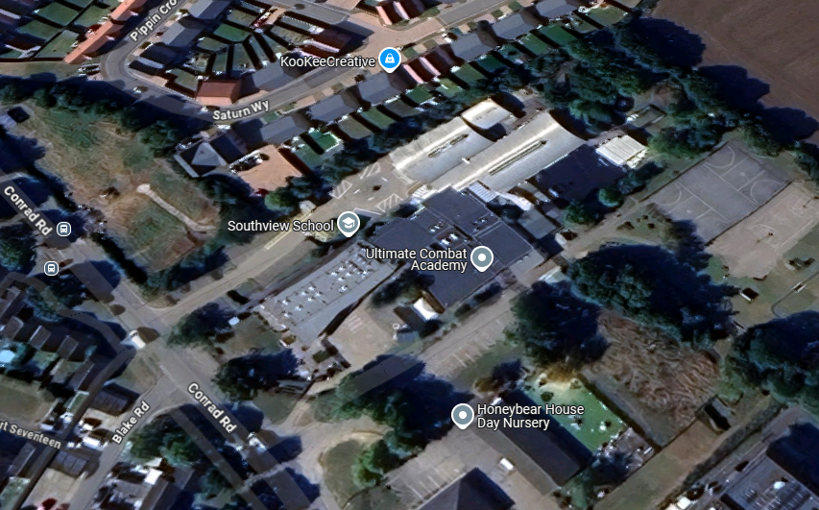
Approximate Red Line Boundary of Site

Anticipated build location

Site Entrance / Exit

Existing Plan Example

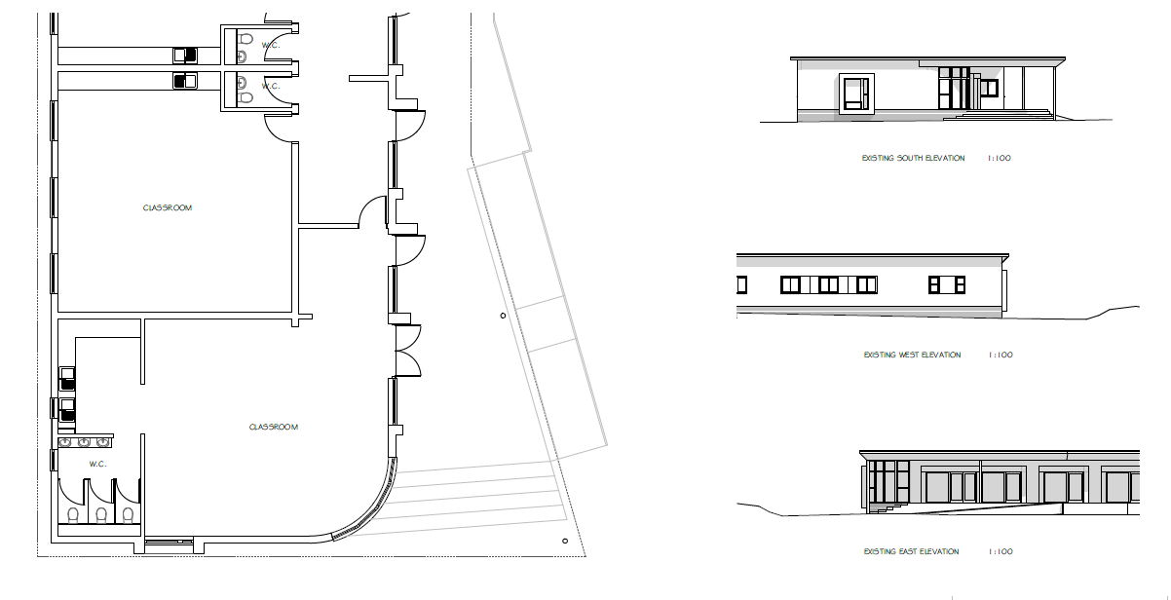
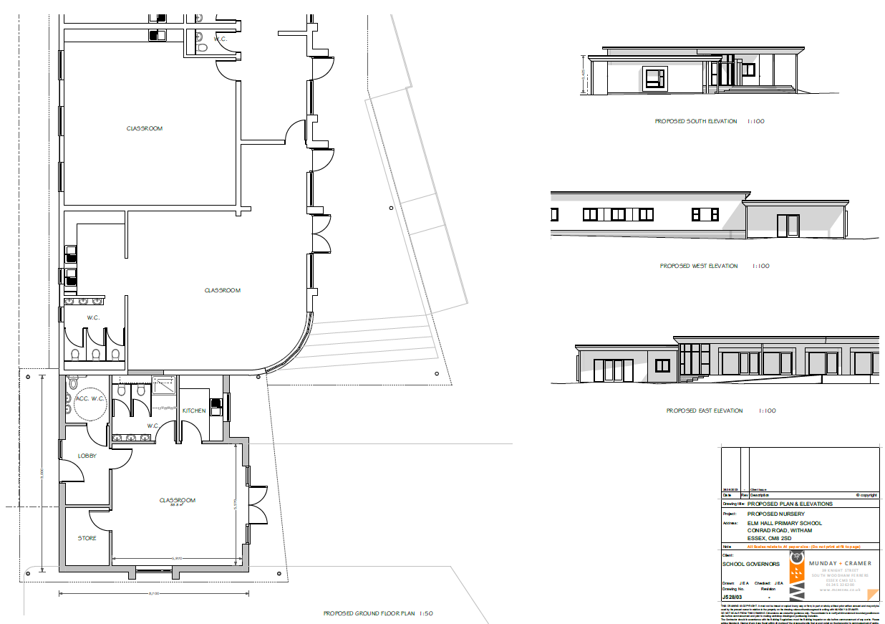
Proposed Plan Example

Photos:
Please provide photos of the proposed project area

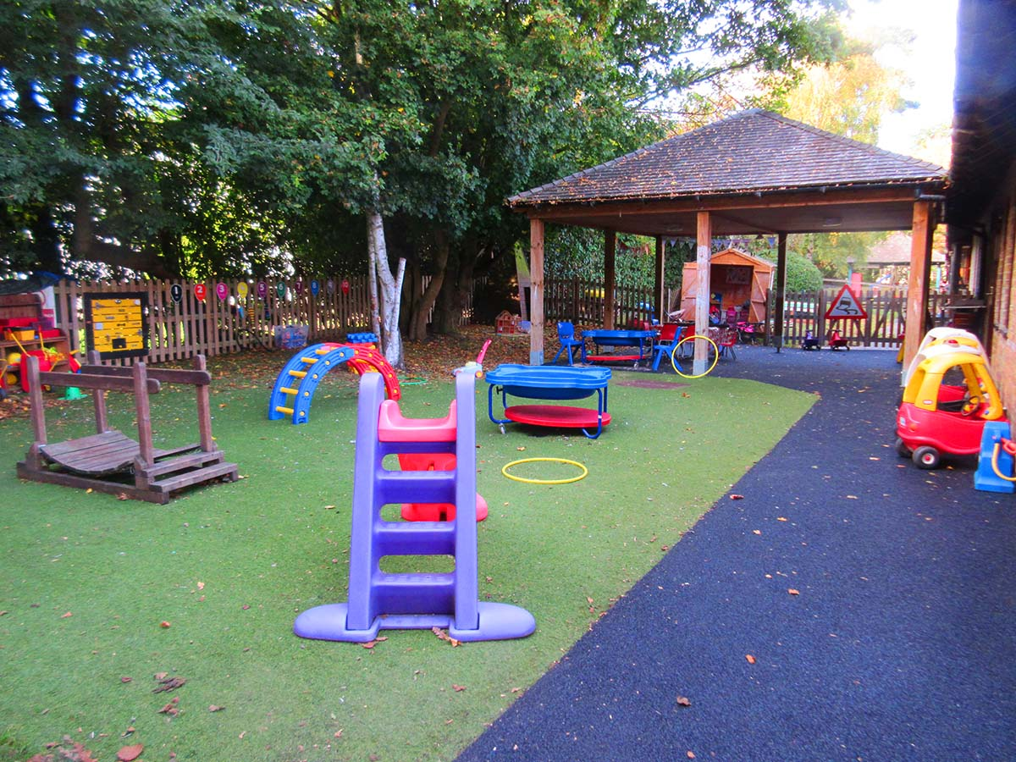

Structure to be removed and replaced with new extended building.

Programme of the works
Please provide a programme of start and completion dates

Approximate duration of the work on site in weeks

Works are intended to commence on 28th July 2025 and works are anticipated to take 10 weeks on site. A breakdown of work activities can be provided by the Contractor upon appoinment.

Logistics:
Provide detail of how the works will be carried out should your provision remain open during the works

The planned works involve the demolition of the existing pergola in the play area, followed by the construction of a new nursery school extension on the same site. All activities will be carried out in phases to minimise disruption to the daily operation of the nursery and to ensure the safety and well-being of children, staff and visitors at all times.

Site Access and Segregation
- A secure and clearly marked hoarding system will be erected around the construction site perimeter prior to any works commencing. This will be erected on a weekend period. This will prevent any access and clear separation from other nursery activities.
- Contractor access will be via a dedicated entrance point, separate from the main access used by parents and children.
- Deliveries and vehicle movement will be schedules outside drop off and pick up times.
Phasing and timing of works
- The demolition of the pergola will be carried out during a weekend to prevent exposure of noise and dust during nursery hours.
- Construction activities will then proceed in line with the programme with no high-noise or high-risk activities conducted during nursery operated hours.
Safety measures for children
- The construction area will be completed enclosed with lockable gates and visual barriers to prevent curiosity from children.
- Additional temporary fencing inside the nursery play area to provide a buffer zone between play areas and construction zone.
- The nursery’s fire evacuation routes will be reviewed and adjusted in collaboration with the contractor to ensure continued compliance and safe egress.

Quotes:
Please provide scanned pdf copies of your chosen quotes for the Project.

Quote 1 - JB Builders Quote dated 230/2/2025 £72,265.13
Quote 2 - 123 Construction Quote 14/02/2025 £84,253.11
Quote 3 - BuildIt Quote 02/02/2025 £67,258.16

Prefered Contractor
Quote 3 - BuildIt Quote 02/02/2025 £67,258.16

Approximate value of work
£250,000
Planning
Is Planning Approval Required? YES/NO (Please Delete)
Has Planning Approval been achieved? YES/NO (Please Delete)
Planning application number (if required): 25/00123/FUL – Basildon Council
Building Control Approval
Provide a statement of how you intend to achieve Local Building Control sign off (including Local Fire Officer) and how the design intends to consider accessibility for less able building users and visitors for your proposed works.

M+C will submit building regulations details to the local authority for approval prior to the start of works on site. The programme shows a period in June 2025 for this process. No works will commence until approval is obtained, and a building control officer is appointed to the works. M+C will manage the periodic building control reviews on site with the local authority building control officer and will obtain the building control certification upon completion of the works and prior to occupation and use of the new building.
The proposed design considers access and facilities for disabled people. The entrance door will have a level access and there will be a new accessible WC on the ground floor of the proposed nursery. The design of the WC meets Doc M requirements.

Declaration - to be completed by Applicant
I have read the Checklist for School Building Projects and have taken and/or will take note of its contents in relation to this project I understand that approval of this EYBid1 application does not constitute approval to proceed with the works, and any expenditure to date is at the risk of the applicant. Please tick o
I understand that this Consent does not constitute technical approval of the project and should not be used for this purpose. Any technical review of the proposal by ECC is purely for the purposes of Capital Funding Approval and suitable technical expertise must be employed directly by the applicant to ensure all standards are achieved. Please tick o
I confirm that no works will commence on site until such time as EYBid2 Stage 2 is completed approval is granted Please tick o
Name: Joe Bloggs
Signed:
Position: Nursery Owner/ Manager
Date: 1st May 2025
Please submit this EYBid1 form with your Early Years and Childcare Infrastructure Development Capital Funding 2025 Application Form to satisfy Question 2 of the evaluation criteria within this application.

