
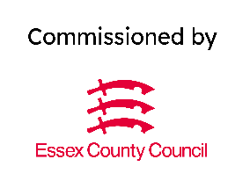
- Early years setting gains FEEE2 parental consent.
- Early years setting identifies children and shares list with the Essex Child and Family Wellbeing Service (ECFWS) - healthy family team.
- Early years setting, ECFWS - healthy family team and parent identify date and venue for review.
- Invitation sent to parent.
- Integrated review time, date and venue agreed and confirmed with ECFWS – Healthy Family Team.
- Meeting takes place and agreed outcomes are shared with early years setting, ECFWS - healthy family team and parent and placed in the healthy child record (red book) and or action plan as required.
- Next steps and referral made to other professionals, if necessary.
NHS Healthy Child Programme – Ages and Stages Questionnaire 3

EYFS Two-Year-Old Progress Check
NHS Healthy Child Programme Ages and Stages Questionnaire

Please note: It is important that following the review, if concerns later develop, the early years setting should liaise with the parent and ECFWS- healthy family team in order to support the child further or to make a relevant and appropriate referral to other professionals for further support.

The Integrated Review for 2-Year- olds
NHS Healthy Child Programme Ages and Stages Questionnaire

