Essex County Council

Funded early education entitlement for two, three and four-year-olds

Headcount and early years pupil premium user guide
Contents

Introduction 3
Accessing the Provider Portal 4
Headcount 5
Viewing messages 5
Executing a task 6
Editing child details 7
Adding a child 9
Removing a child 10
Editing the headcount information 10
Exporting headcount information 11
Submitting headcount information 11
Early Years Pupil Premium 12

Introduction

We collect information about claims for the funded early education entitlement. This is funding for two, three- and four-year olds. The Provider Portal is a secure and easy way for you to give us this information, in one headcount process.

This guide will show you how to log in and update your records in the new Provider Portal. Read it before you give us your headcount details.

There are three headcount tasks each term:

- Forecast - anticipated hours for the 50 per cent interim payment. Usually paid during the first two weeks of the funded term. We usually collect the data one week before the end of the previous term.

- Actual Headcount - actual hours collected as at Headcount Day on the third Thursday each term. It’s paid within seven weeks of Headcount Day.

- Amendment - late Claims for children starting after headcount day and adjustments for errors. Collected after half term deadline three weeks before the end of term and paid after the end of term.

You'll need all the funded children’s parent / carer agreement forms to update the headcount details. Make sure they're completed in full. You can only claim if a parent completes and signs a new form.

Please note:

- never overwrite a child record.
- if a child leaves, please add the last date of attendance as the leave date during the term in which they leave.
- images in this document may vary to those on the Provider Portal

Accessing the Provider Portal

- Go to the Essex County Council Early Years and Childcare website.

- Click on the tile on the right-hand side to access the Provider Portal



- Enter your username and password and click Log In.

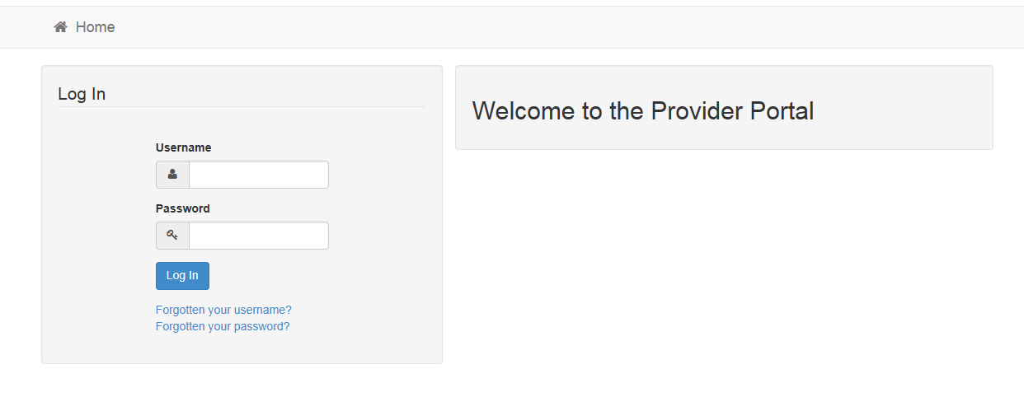

- Enter your secret answer and click Submit to continue to the Provider Portal home page. If there are any announcements on this page, read them before going to the home page.

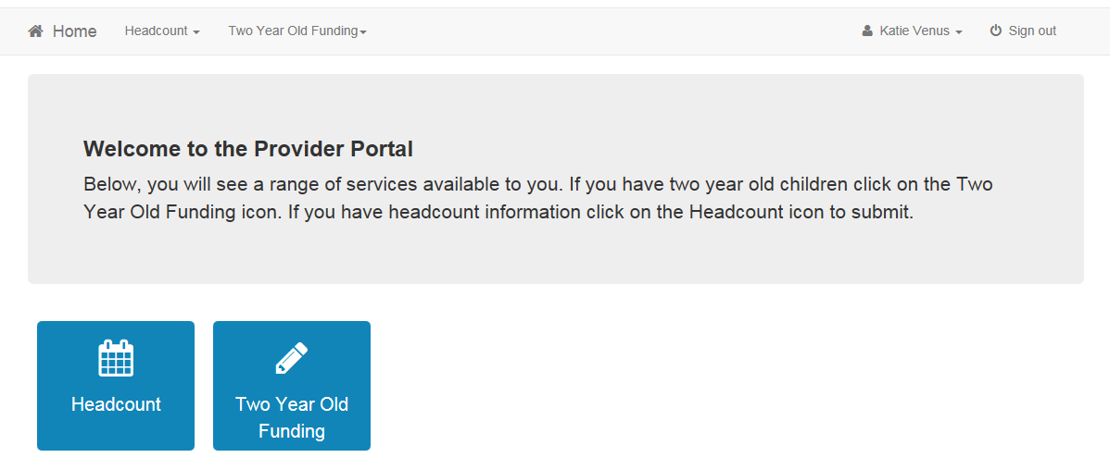

Headcount

The Provider Portal has a dedicated Headcount screen. You can access it by clicking the Headcount button on the home page.

You will then see the following screen

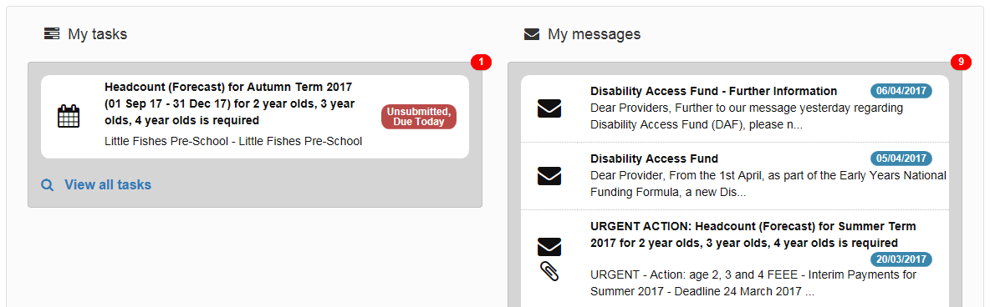

Here you will be able to access your tasks and messages.

For each headcount data collection (forecast, actual and amendment) we will issue a task and a message. Always read the message before executing the task.

Viewing messages

You will see the My messages panel on the Headcount and Funded Early Entitlement for Two Year Olds home pages. It lists the messages sent by Essex County Council about these topics.

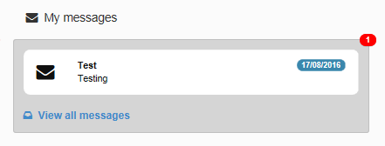

- Click on a message to display the details. Alternatively, click the view all
messages link to display the My messages page.

- If required, click on the Subject or Received heading to sort the list.

- Click on a message to display the detail.

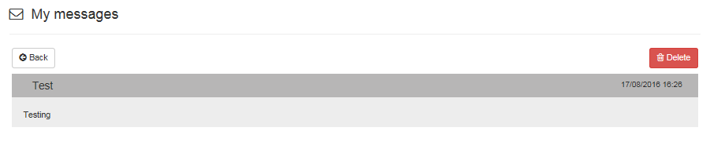

- Click the Back button to display the homepage.

Executing a task

- Click on a task to display the headcount details. A row is displayed for each child at the service for whom a claim is being made.

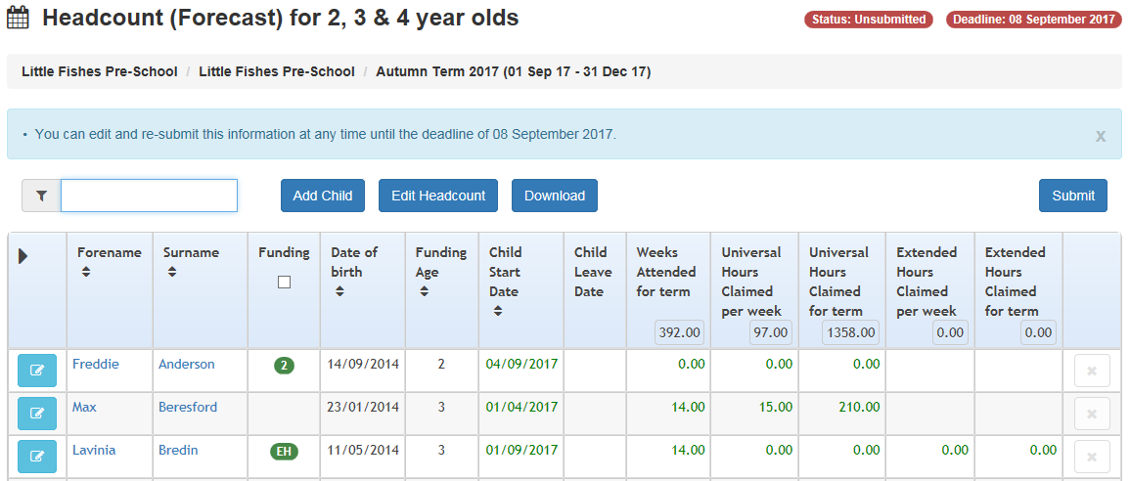

The table is pre-populated. It shows children known to have attended the service previously.
2. If required, enter two or more characters of the surname to filter the list. Before midday on the task deadline date, you can edit child details, headcount details and add new children.

3. Edit existing details and add children as required.

4. When all the additions and changes to the headcount are complete, click Submit. You can resubmit the details as many times as needed before the deadline date.

Editing child details

Child records that need carer information will be highlighted in red. You can edit any child record before the task deadline date.

- Click on the Change Child Details link to the left of each child record to edit the Personal Details.

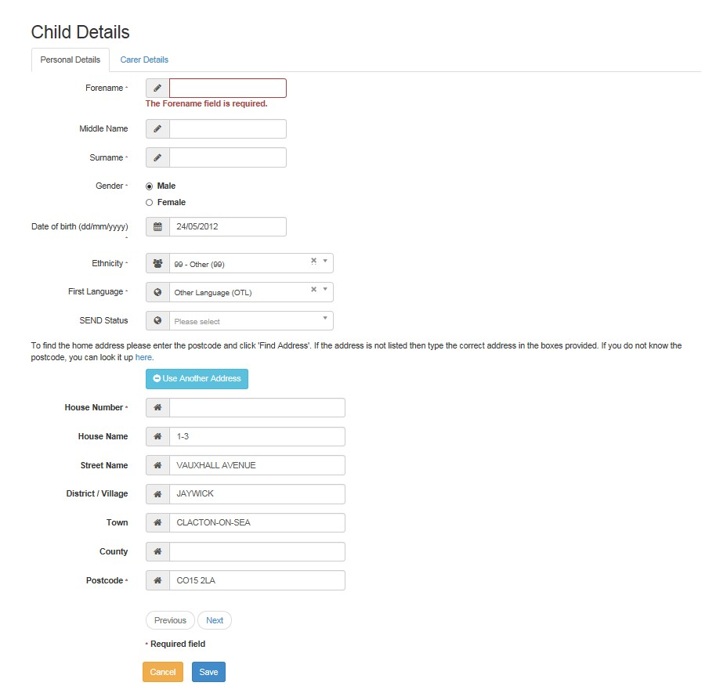
2. Enter or edit the required details and click Next to proceed to the Parent / Guardian Details tab.

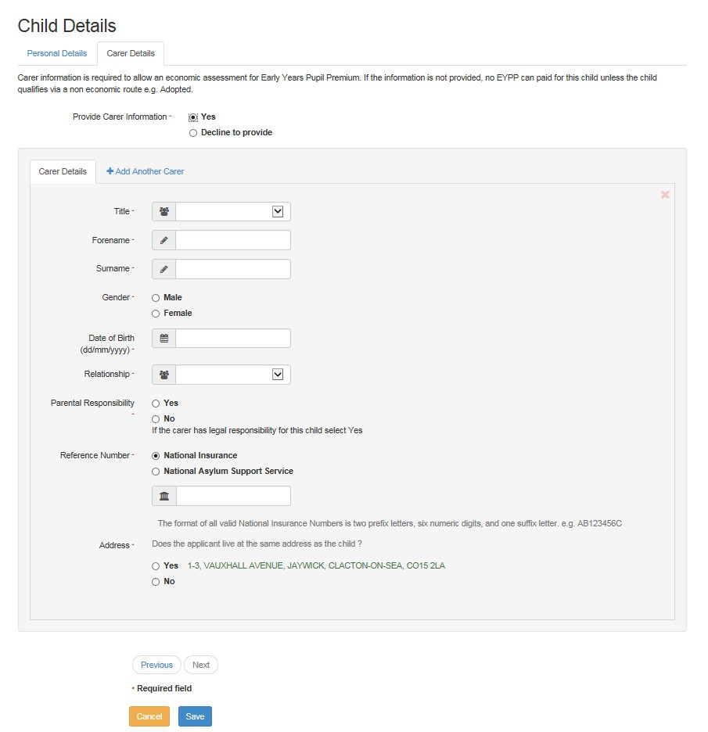

The system has to check if a child is eligible for the early years pupil premium on economic grounds. So, you must record parent or guardian details here.

3. Enter the Parent / Guardian details or select Decline to provide and click Save to update the child record.

Adding a child

- Click the Add Child button from the Headcount homepage.

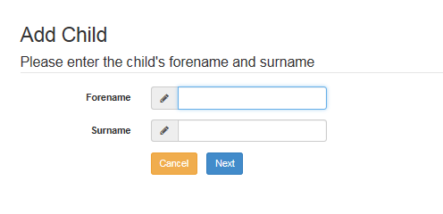

- Enter a Forename and Surname and click the Next button.

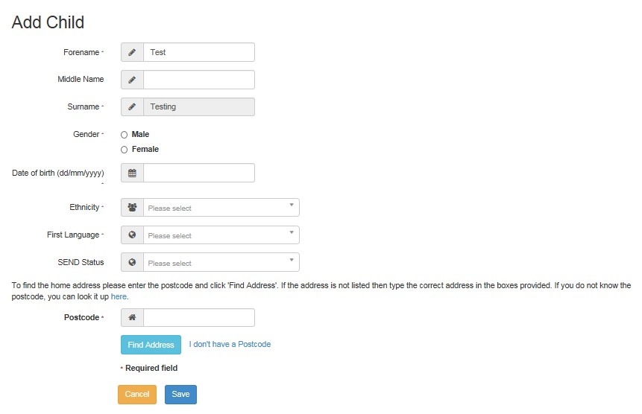

- Select Gender and enter the required details. Click the Save button to create the child record.

You need to complete the parent / guardian details tab if the child is the age to receive 3 and 4-year-old funding.

You can copy across the date of birth and 30-hour funding eligibility code if the child’s record already exists.

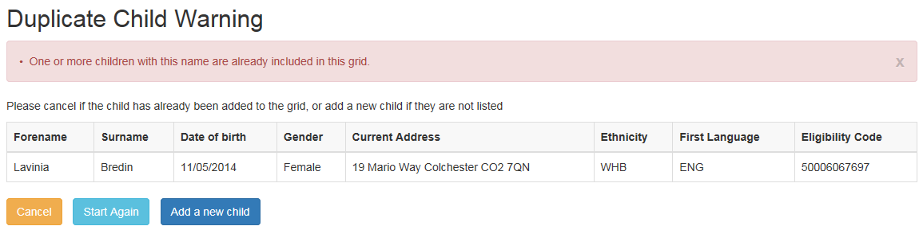

Removing a child

Do not delete a child's records, even if the child won’t be attending this term or has not started a placement with you. Instead add a leave or end date. This should be the date the child last attended. You should do this in the same term they leave.

- Click on Edit Headcount when in the live Headcount task.
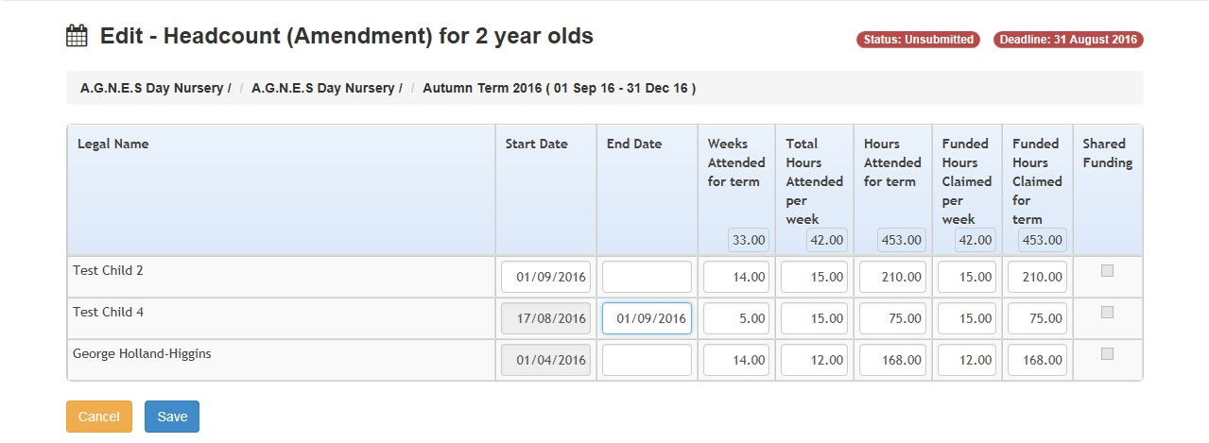
- In the End Date field, enter the date the child last attended with you. If they did not begin their placement, enter the first date of the term that the task relates to, for example 01/09/2017.

- Click Save to be taken back to the Task.

Editing the headcount information

Headcount details can be edited before midday on the task deadline date.

- Click the Edit Headcount button to display the Edit - Headcount page.

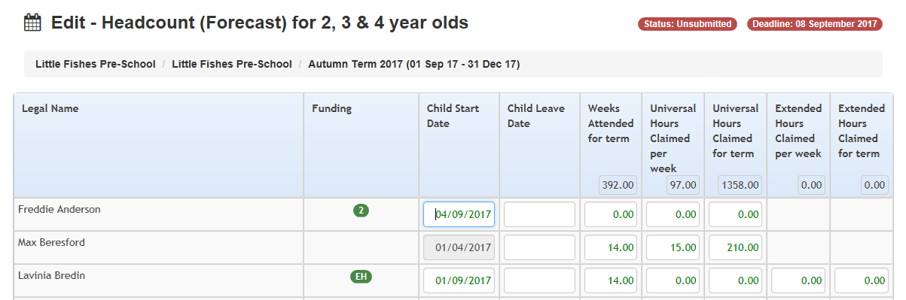

If the child is on roll at another service, the Shared Funding indicator is automatically shown, even if they are not claiming funding.

Edit the details as required working from left to right:

- enter a Child Leave Date and 0 hours if they no longer claim FEEE with you
- enter Weeks Attended for the term - no more than the maximum for the term
- enter Total Hours Attended per week (funded and non-funded) to automatically calculate Hours Attended for term
- manually, amend the Universal Hours Claimed per week and any Extended Hours to match the Parent Agreement Form

Universal or extended hours claimed per week or per term are automatically calculated. Check the funded hours calculated. They must match the hours on the newly signed parent agreement form. If you are not claiming the full entitlement, especially where there is shared funding, please update these fields manually.

- If the child’s 30 hours check is successful fill in the additional columns for extended hours claimed per week and extended hours claimed for term.

- Click Save. Save regularly as the system will time out after 30 minutes and you may lose all your data input.

Exporting headcount information

If required, click the download button to export the headcount details to an Excel spreadsheet.

Submitting headcount information

When you've entered and saved all the data needed for a task, submit it to us. We can then validate and process it.

1. Click the submit button to send the headcount information.

2. The Submission Declaration page is displayed.

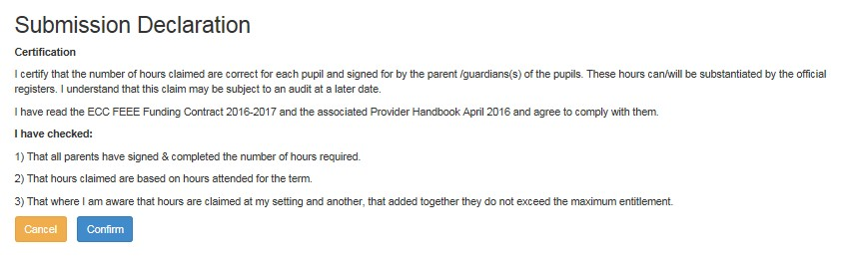

3. Click the Confirm button. Then click Yes when asked if you are sure you wish to submit the information. You will then be returned to the Provider Portal Home page.

You can edit child and headcount information up until midday of the task deadline date. You will need to Submit after each edit. This will ensure that you have sent us the latest details..

Early Years Pupil Premium

We will carry out economic EYPP checks against the carer details added against a child. See Editing Child Details for instructions on how to add carer information.

The data must exactly match that held by the Department for Work and Pensions (DWP), Home Office etc. If it doesn’t, EYPP won’t be assigned. The check will fail if there is an error or difference in the name, date of birth and NI/NASS number. You should double check your data entry as once the check is run we can’t check it again until next term.

We run the check for EYPP once per term. It’s done just before the Actual Headcount payments are extracted. We will send you a payment report after the EYPP check and payment is made. The report will show which children have received EYPP. You will receive EYPP with the Actual headcount payment.

It may take 3 months or more for DWP to assess the annual salary for Universal Credit claimants. This may delay further benefits including EYPP.

For any funded early education entitlement (FEEE) queries please email earlyyearsdata@essex.gov.uk

