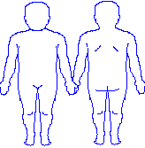

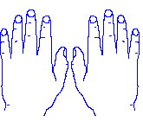
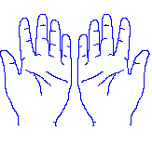

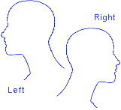

Colour Key
Black | Bruising
Green | Swelling and inflammation
Red | Burns
Yellow | Cuts & or grazes
Pink | Marks (anything else)
Blue | Pain

