SAFEGUARDING AND CHILD PROTECTION POLICY FOR [INSERT NAME] EARLY YEARS PROVIDER

APPROVED BY: [INSERT NAME]

DATE: [INSERT DATE]

POLICY REVIEW DATE: [INSERT DATE]

Designated Safeguarding Lead

Deputy Designated Safeguarding Lead | Add names of all deputies if more than one


INSERT PROVIDER LOGO AND / OR STATEMENT

Contents

1 | Introduction
2 | Statutory framework
3 | Roles and responsibilities
4 | Types of abuse / specific safeguarding issues
5 | Children potentially at greater risk of harm
6 | Procedures
7 | Working with other partners to keep children safe
8 | Training
9 | Information sharing and confidentiality
10 | Child protection records
11 | Allegations about members of the workforce
12 | Physical intervention and use of reasonable force
13 | Online Safety
14 | Use of mobile phones
15 | Use of cameras, photography and images
16 | Attendance
Appendix A | Children and Families Service Map and Key Contacts
Appendix B | Essex Windscreen of Need and levels of intervention
Appendix C | Signs and symptoms of abuse

1. Introduction
‘Every child deserves the best possible start in life and the support that enables them to fulfil their potential.

Children learn best when they are healthy, safe and secure, when their individual needs are met, and when they have positive relationships with the adults caring for them.’

Statutory framework for the early years foundation stage (DfE 2025)

Childminders must take all necessary steps to keep children safe and well by:

- Safeguarding children
- Ensuring the people who have contact with children are suitable
- Promoting good health
- Supporting and understanding behaviour
- Maintaining records, policies, and procedures

This policy sets out the framework for safeguarding and promoting the welfare of the children who attend my setting, to ensure I provide a safe, caring environment in which children can develop and flourish. Keeping children safe is at the heart of everything I do and underpins all processes and policies. It is only by working in partnership, that we truly keep children safe and it is important that my safeguarding values are understood and shared by all children and their parents / carers.

2. Statutory framework
There is government guidance set out in Working Together to Safeguard Children (DfE, 2024) on how agencies must work in partnership to keep children safe. This guidance places a shared and equal duty on three Safeguarding Partners (the Local Authority, Police and Health) to work together to safeguard and promote the welfare of all children in their area under multi-agency safeguarding arrangements. These arrangements sit under the Essex Safeguarding Children Board (ESCB). In Essex, the statutory partners are Essex County Council, Essex Police and three NHS Integrated Care Boards covering the county.

Early years settings have a duty under section 40 of the Childcare Act 2006 to comply with the safeguarding and welfare requirements of the Early Years Foundation Stage, under which settings are required to take necessary steps to safeguard and promote the welfare of young children.

In addition to national statutory guidance, in Essex, all professionals must work in accordance with the SET Procedures. This is local guidance which sets out the child protection and safeguarding arrangements in Essex.

I also work in accordance with the following legislation and guidance:

- Statutory framework for the early years foundation stage (DfE, 2025)
- Working Together (DfE, 2023)
- What to do if you’re worried a child is being abused (HMG, 2015)
- The Prevent Duty guidance (Home Office, 2015)
- Effective Support for Children and Families in Essex (ESCB 2024)
- Understanding and supporting behaviour - Safe practice for schools (Essex County Council)
- Children Act (HMG, 1989)
- Children Act (HMG, 2004)
- Childcare Act (HMG, 2006)
- Children and Social Work Act ( HMG, 2017)
- Keeping children safe in education (DfE, 2025)
- Counter-Terrorism and Security Act (HMG, 2015)

3. Roles and responsibilities
The Statutory framework for the early years foundation stage (DfE, 2025) requires childminders to take lead responsibility for safeguarding children in every setting, and to act as the Designated Safeguarding Lead (DSL). As a childminder, I take this lead responsibility and I am the DSL, liaising with local statutory children's services agencies, including Essex Social Care and other agencies, as required.

4. Types of abuse / specific safeguarding issues
Information about abuse and harm including examples of specific safeguarding issues is set out below. Further information about types of abuse and harm is given in:

- What to do if you’re worried a child is being abused: Advice for practitioners (HMG, 2015)
- Keeping children safe in education (DfE, 2025)

Abuse is a form of maltreatment of a child. Somebody may abuse or neglect a child by inflicting harm, or by failing to act to prevent harm. A child may be abused by an adult or adults or another child or children – the four categories of abuse are:

- Physical - may involve hitting, shaking, throwing, poisoning, burning or scalding, drowning, suffocating or otherwise causing physical harm to a child. Physical harm may also be caused when a parent / carer fabricates the symptoms of, or deliberately induces, illness in a child

- Emotional - the persistent emotional maltreatment of a child such as to cause severe and adverse effects on the child’s emotional development

- Sexual - forcing or enticing a child or young person to take part in sexual activities, not necessarily involving violence, whether or not the child is aware of what is happening. Sexual abuse can take place online, and technology can be used to facilitate offline abuse. Sexual abuse is not solely perpetrated by adult males. Women can also commit acts of sexual abuse, as can other children

- Neglect - persistent failure to meet a child’s basic physical and/or psychological needs, likely to result in the serious impairment of the child’s health or development

Harmful sexual behaviour
It is normal for some children to display sexualised behaviour towards other children as they develop. However, harmful sexual behaviour (HSB) is developmentally inappropriate sexual behaviour which is displayed by children, and which may be harmful or abusive (derived from Hackett, 2014). It may also be referred to as sexually harmful behaviour or sexualised behaviour. HSB encompasses a range of behaviour, which can be displayed towards younger children, peers, older children, or adults. It is harmful to the children and young people who display it, as well as those it is directed towards.

I understand that, if a child's sexual behaviour is not developmentally appropriate or expected for their age, it is important to respond quickly, before the behaviour becomes harmful to that child or other children. I recognise HSB may also be a sign that a child has suffered their own trauma or abuse and I will respond to ensure they receive the right help at the right time to address the concerning behaviour.

Domestic abuse
Domestic abuse is any type of controlling, coercive, threatening behaviour, violence, or abuse between people who are, or who have been in a relationship, regardless of gender or sexuality. It can also happen between adults who are related to one another and can include physical, sexual, psychological, emotional, or financial abuse.

Being exposed to domestic abuse in childhood is child abuse and can have a significant and lasting impact. Children may experience domestic abuse directly, but they can also experience it indirectly. Either can have a serious effect on a child's behaviour, brain development and overall wellbeing, and also compromise the child’s basic need for safety and security.

In Essex, the Southend, Essex and Thurrock Domestic Abuse Board (SETDAB) is responsible for designing and implementing the Domestic Abuse Strategy and provides advice, guidance and resources to support work around domestic abuse.

Risk in the community
I understand that safeguarding incidents and behaviours can be associated with factors outside a child’s home or my setting, and that there are risks that exist in the community. I am aware of contextual safeguarding and am therefore mindful of whether wider environmental factors present in a child’s life are a threat to their safety and / or welfare. I always consider relevant information when assessing any risk to a child and will share it with other agencies when appropriate, to support better understanding of a child and their family. This is to ensure that our children and families receive the right help at the right time.

Emotional wellbeing
Children’s personal, social, and emotional development (PSED) is crucial for them to lead healthy and happy lives and is fundamental to their cognitive development. We understand that a child’s positive wellbeing is vital and that poor wellbeing can, in some cases, be an indicator that a child has suffered or is at risk of suffering abuse, neglect or exploitation. I recognise that where children have suffered abuse or other potentially traumatic adverse childhood experiences, this can have a lasting impact throughout childhood, adolescence and into adulthood.

Prevention of radicalisation
Children can be vulnerable to radicalisation and extremism in the same way they are vulnerable to other safeguarding issues. Keeping Children Safe in Education (DfE, 2023) defines the following:

Extremism: the vocal or active opposition to our fundamental values, including democracy, the rule of law, individual liberty and the mutual respect and tolerance of different faiths and beliefs. This also includes calling for the death of members of the armed forces

Radicalisation: refers to the process by which a person comes to support terrorism and extremist ideologies associated with terrorist groups

Terrorism: an action that endangers or causes serious violence to a person/people; causes serious damage to property; or seriously interferes or disrupts an electronic system. The use or threat must be designed to influence the government or to intimidate the public and is made for the purpose of advancing a political, religious, or ideological cause.

The Counter-Terrorism and Security Act (HMG, 2015) placed a duty on childcare providers and schools. Under section 26 of the Act, childcare providers and schools are required, in the exercise of their functions, to have ‘due regard to the need to prevent people from being drawn into terrorism’. This duty is known as the Prevent Duty.

Channel is a national programme which focuses on providing support at an early stage to people identified as vulnerable to being drawn into terrorism. Prevent referrals may be passed to a multi-agency Channel panel, which will discuss the individual referred to determine whether they are vulnerable to being drawn into terrorism and consider the appropriate support required. A representative from an educational setting may be asked to attend the Channel panel to help with this assessment. An individual’s engagement with the programme is entirely voluntary at all stages.

So-called ‘Honour Based Abuse’
So-called ‘honour-based’ abuse (HBA) encompasses incidents or crimes which have been committed to protect or defend the honour of the family and / or the community, including Female Genital Mutilation (FGM), forced marriage, and practices such as breast flattening.

Abuse committed in the context of preserving ‘honour’ often involves a wider network of family or community pressure and can include multiple perpetrators. It is important to be aware of this dynamic and additional risk factors when deciding what form of safeguarding action to take. All forms of HBA are abuse (regardless of the motivation) and should be handled and escalated as such. Professionals in all agencies, and individuals and groups in relevant communities, need to be alert to the possibility of a child being at risk of HBA, or already having suffered HBA.

Female Genital Mutilation
FGM comprises all procedures involving partial or total removal of the external female genitalia or other injury to the female genital organs. It is illegal in the UK and a form of child abuse with long-lasting harmful consequences. Information about FGM is available on the National FGM Centre website.

Forced marriage
Forcing a person into a marriage is a crime in England and Wales. A forced marriage is one entered into without the full and free consent of one or both parties and where violence, threats or any other form of coercion is used to cause a person to enter into a marriage. Threats can be physical or emotional and psychological. A lack of full and free consent can be where a person does not consent or where they cannot consent (if they have learning disabilities, for example). Nevertheless, some perpetrators use perceived cultural practices as a way to coerce a person into marriage.

The Forced Marriage Unit has published statutory guidance and multi-agency guidelines, which are available on the GOV.UK website. The Forced Marriage Unit can also provide advice and information: call 020 7008 0151 or email fmu@fcdo.gov.uk.

Breast Flattening
Breast flattening is the process during which young pubescent girls’ breasts are ironed, massaged, flattened and/or pounded down over a period of time (sometimes years) in order for the breasts to disappear or delay the development of the breasts entirely. Information about breast flattening is also available on the National FGM Centre website.

5. Children potentially at greater risk of harm
I recognise that some children may potentially be at risk of greater harm and require additional help and support. These may be children with a Child in Need or Child Protection Plan, those in Care or previously in Care or those requiring wellbeing support. I work with Social Care and other appropriate agencies to ensure there is a joined-up approach to planning for these children and that they receive the right help at the right time.

I also understand that children with special educational needs (SEN) and / or disabilities can face additional safeguarding challenges. Barriers can exist when recognising abuse and neglect in this group of children. These can include:

- assumptions that indicators of possible abuse such as behaviour, mood and injury relate to the child’s disability, without further exploration
- that they may be more prone to peer group isolation than others
- the potential to be disproportionally impacted by things like bullying, without outwardly showing signs
- communication difficulties in overcoming these barriers

Children with SEND may require additional help and support to ensure they are appropriately safeguarded.

6. Procedures
I have a duty to identify and respond to suspected / actual abuse or disclosures of abuse, and always follow the procedures set out below.

All action is taken in accordance with the following guidance:

- Essex Safeguarding Children Board guidelines - the SET (Southend, Essex and Thurrock) Child Protection Procedures (ESCB, 2025)
- Statutory framework for the early years foundation stage (DfE, 2025)
- Keeping Children Safe in Education (DfE, 2025)
- Working Together to Safeguard Children (DfE, 2023)
- ‘Effective Support for Children and Families in Essex’ (ESCB)
- PREVENT Duty - Counter-Terrorism and Security Act (HMG, 2015)

Where there is risk of immediate harm, concerns will be referred by telephone to the Children and Families Hub and / or the Police. Less urgent concerns or requests for support will be sent to the Children and Families Hub via Essex Effective Support . I may also seek advice from Essex Social Care or another appropriate agency about a concern if I am unsure how to respond to it.

Wherever possible, I will share any safeguarding concerns, or an intention to refer to Children’s Social Care, with parents / carers. However, I will not do so where it is felt that it could place a child at greater risk of harm or impede a criminal investigation. If it is necessary for another agency to meet with a child in the setting, I will always seek to inform parents or carers, unless advised not to by that agency. On occasions, it may be necessary for me to consult with the Children and Families Hub and / or Essex Police for advice on when to share information with parents / carers.

7. Working with other partners to keep children safe
As part of interagency safeguarding arrangements, I am sometimes required to attend statutory meetings called for children currently at my setting or previously known to me, and to contribute to the discussions. Where I am required to submit a report for these meetings, and where possible and appropriate, I will share this in advance with the parent / carer. Any concerns about the plan and / or a child’s welfare will be discussed and recorded at these meetings, unless to do so would place the child at further risk of significant harm.

If a child is subject to a Care, Child Protection, or a Child in Need plan, I will ensure the child is monitored regarding their setting attendance, emotional wellbeing, EYFS progress, welfare, and presentation. If my setting is part of the core group, I will attend meetings, provide appropriate information, and contribute to the plan.

8. Training
Childminders are required to access a training course to enable them to identify, understand and respond appropriately to signs of possible abuse and neglect – and to liaise with local statutory children's services agencies as required. I undertake Level 3 Child Protection training every two years and also keep my knowledge up to date in other ways, through other relevant training available. I keep a record of all child protection training attended.

9. Information sharing and confidentiality
Sharing information is a key part of safeguarding work and decisions about how much information to share, with whom and when, can have a profound impact on a child’s life.

Where there are concerns about the safety of a child, the sharing of information in a timely and effective manner between organisations can reduce the risk of harm. Whilst the Data Protection Act 2018 places duties on organisations and individuals to process personal information fairly and lawfully, it is not a barrier to sharing information, where the failure to do so would result in a child or vulnerable adult being placed at risk of harm. Similarly, human rights concerns, such as respecting the right to a private and family life, would not prevent sharing information where there are real safeguarding concerns. Fears about sharing information cannot (and will not) stand in the way of the need to safeguard and promote the welfare of children at risk of abuse or neglect.

Confidentiality is an important part of safeguarding, particularly in the context of child protection. In accordance with statutory requirements, where I identify a child protection concern, it may require further referral to and subsequent investigation by appropriate authorities. I am therefore not able to, and therefore never will, guarantee confidentiality or promise to keep a secret about a safeguarding concern (including to children and parents / carers), where my statutory duties do not allow me to.

Where a child is attending another setting, it may be necessary for me to link with the them to share certain information, where it is in the best interests of the child. Wherever possible, I will inform parents / carers of the intention to do this, unless to do so would place the child at further risk.

Information sharing can help to ensure that a child receives the right help at the right time and can prevent a concern from becoming more serious and difficult to address.

10. Child protection records
Well-kept records are essential to good child protection practice. I record any concerns about a child in my care and share these with other agencies as appropriate.

If I receive a disclosure of abuse or notice signs or indicators of abuse, it is recorded as soon as possible (noting what was said or seen and, if appropriate, using a body map to record), giving the date, time, and location. All records are dated and signed and include the action taken.

I will keep any records relating to child protection on an individual child protection file for that child (which is separate to any other child file). All child protection records are stored securely and confidentially until the child transfers to another educational setting.

Where a child transfers from my setting to another setting or school, their child protection record will be forwarded to the new educational setting. This will be marked ‘Confidential’ and for the attention of the DSL at the new setting, with a return address on the envelope so it can be returned to me if it goes astray. I will obtain evidence that the paperwork has been received by the new setting, and then destroy any copies I hold. Where appropriate, I may also contact the new setting in advance of the child’s move there, to enable planning so appropriate support is in place when the child arrives.

Where a child joins my setting, I will request child protection records from the previous educational setting (if applicable, and if none are received).

Where a child is also attending another setting, I will share any child protection records where appropriate and where it is in the best interests of the child. I may also link with other settings when there is a need to so and will be transparent with parents about this (unless to do so would place a child at further risk of harm).

11.​ Allegations about members of the children’s workforce
I work in accordance with statutory guidance and the SET Procedures (ESCB) in respect of allegations against an adult working with children (in a paid or voluntary capacity).

Keeping Children Safe in Education (DfE 2025) and the SET procedures (ESCB 2025) set out the procedures in respect of allegations against an adult working with children (in a paid or voluntary capacity). These procedures should be followed where an adult has:

- behaved in a way that has harmed a child, or may have harmed a child and/or
- possibly committed a criminal offence against or related to a child, and/or
- behaved towards a child or children in a way that indicates he or she may pose a risk of harm to children, and/or
- behaved or may have behaved in a way that indicates they may not be suitable to work with children

In the event of any concern being raised about me, where the above criteria apply, the SET Procedures (ESCB, 2025) require me to report this to the Duty Local Authority Designated Officer (LADO) at the Essex Workforce Allegations Team. The LADO may be contacted on 03330 139 797 or by email on lado@essex.gov.uk. I will do this within one working day (or sooner via 03330 139797 if immediate safeguarding is required). I will also follow this process in the event of any such allegations being made relating to the conduct and behaviour of an assistant or volunteer.

In accordance with the Statutory framework for the early years foundation stage (DfE, 2025), I will inform Ofsted of any allegations of serious harm or abuse by any person living, working, or looking after children at the premises (whether the allegations relate to harm or abuse committed on the premises or elsewhere). I will notify Ofsted of the action taken in respect of the allegations and will make these notifications as soon as reasonably practicable, but within 14 days of the allegations being made and I am aware that not complying with these requirements without reasonable excuse is committing an offence.

Staffing matters are confidential and I operate within a statutory framework around Data Protection.

12.​ Physical intervention and use of reasonable force
My Behaviour Policy sets out my approach to behaviour for all children and for those with more challenging or harmful behaviour. It also includes information about my approach to physical contact and intervention. I recognise there are some children who have needs that require additional support and a more personalised approach and I always consider all behaviour, and the response to it, in the context of safeguarding.

There are occasions when there is a need for physical contact with children. These may include:

- to comfort a child in distress (appropriate to their age and individual specific needs identified through a risk assessment)
- to direct a child
- for curricular reasons (for example during physical activity, or when we are using music)
- in an emergency, to avert danger to the child or others

The term ‘reasonable force’ covers a broad range of actions used by adults that involve a degree of physical contact to control or restrain children. However, these are exceptional circumstances and do not form part of my routine approach to behaviour. ‘Reasonable’ means using no more force than is needed. I work in accordance with statutory and local guidance on the use of reasonable force and recognise that where intervention is required, it should always be considered in a safeguarding context.

13. Online Safety
Technology forms part of the Statutory framework for the early years foundation stage; computer skills are key to accessing learning. I am aware of the risks to children online and understand that any child can be vulnerable, and that their vulnerability can vary according to age, developmental stage, and personal circumstances.

I help children to begin to learn how to use technology safely, and how to be safe online. I will also engage with parents / carers about online safety to support them in keeping their children safe at home when using technology.

14. Use of mobile phones
Mobile phones are often the only means of contact available and can be helpful in supporting safeguarding arrangements in settings, and during outings. However, in the interests of safeguarding all children in my care, I will ensure that my personal mobile:

- is stored securely [say where] and will be switched off or on silent whilst I am supporting children;

- is not used to take photographs, videos or audio recordings of the children attending my setting;

- is not used to contact parents / carers or children except in the event of an emergency; and

- is not used by any visitors.

15. Use of cameras, photography and images
Most people who take or view photographs or videos of children do so for acceptable reasons. However, due to cases of abuse to children through taking or using images, safeguards are in place.

To keep children safe, I will:

- always obtain consent from parents / carers for photographs or video recordings to be taken, used, or published (for example, on my website or displays);

- ensure only the setting’s designated cameras are used when photographing or videoing children;

- ensure that children are appropriately dressed if photographs or videos are to be taken;

- ensure that children’s names are not displayed alongside any photographs in a public space;

- ensure that personal devices including cameras, mobile phones, tablets, smart watches, or other such technology are not used to take photographs, video, or audio recordings in my setting without prior explicit written consent from the setting;

- ensure that all images are stored securely and in accordance with statutory guidance;

- ensure where professional photographers are used that the appropriate checks, such as those with the Disclosure and Barring Service, references and parental consent are obtained prior to photographs being taken.

16. Attendance
Whilst there is no legal requirement for children to attend a setting before the term after their fifth birthday, I understand the importance of good attendance as a protective factor and also to support a child’s development and wellbeing. Repeated and unexplained absence from a setting can be a concern for a number of reasons:

- it is a potential indicator of abuse or neglect
- it can significantly impact on a child’s progress and / or wellbeing

In accordance with my Attendance Policy [ensure you have an Attendance Policy in place] and as part of safeguarding and Health and Safety procedures, I keep a daily record of the names of the children being cared for on the premises and their hours of attendance. This data is used to identify patterns of absence as they emerge, to ensure any concerns are identified and addressed at an early stage. I also have procedures to follow up on absence and may work with other relevant agencies where it is appropriate to do so, or where there are concerns about a child.

Appendix A: Children and Families Service Map and Key Contacts

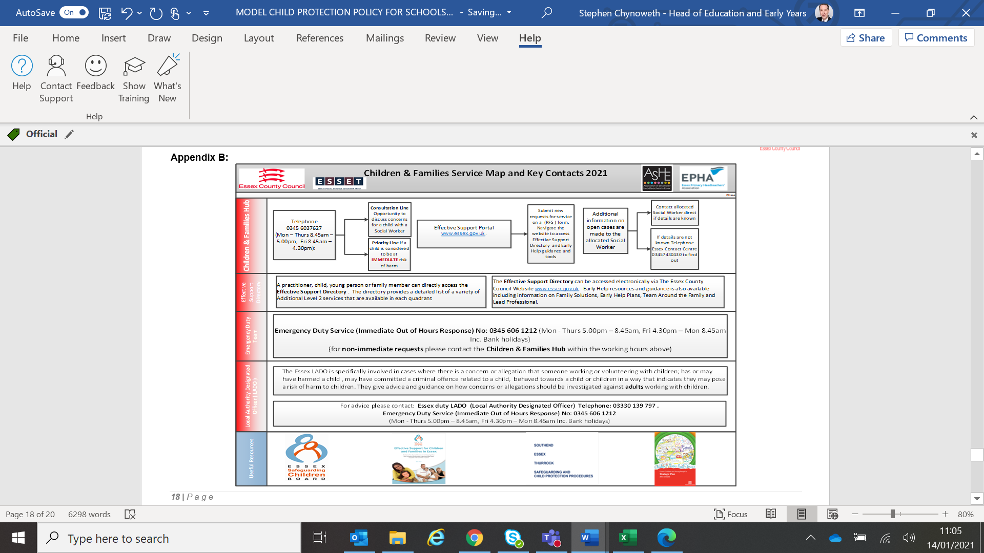

Appendix B: Essex Windscreen of Need and levels of intervention

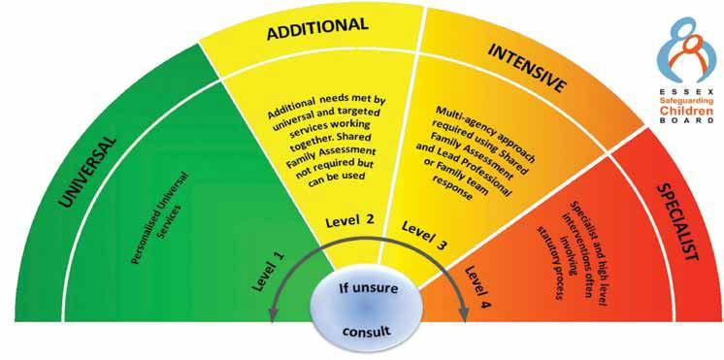

All partners working with children, young people and their families will offer support as soon as we are aware of any additional needs. We will always seek to work together to provide support to children, young people and their families at the lowest level possible in accordance with their needs

Children with Additional needs are best supported by those who already work with them, such as Family Hubs or schools and settings, organising additional support with local partners as needed. When an agency is supporting these children, an Early Help Plan and a Lead Professional are helpful to share information and co-ordinate work alongside the child and family.

For children whose needs are Intensive, a coordinated multi-disciplinary approach is usually best, involving either an Early Help Plan or a Shared Family Assessment (SFA), with a Lead Professional to work closely with the child and family to ensure they receive all the support they require. Examples of intensive services are children’s mental health services and Family Solutions.

Specialist services are where the needs of the child are so great that statutory and/or specialist intervention is required to keep them safe or to ensure their continued development. Examples of specialist services are Children’s Social Care or Youth Offending Service. By working together effectively with children that have additional needs and by providing coordinated multi-disciplinary/agency support and services for those with intensive needs, we seek to prevent more children and young people requiring statutory interventions and reactive specialist services.

Appendix C: signs and symptoms of abuse
Signs of possible abuse

- Physical - children with frequent injuries, unexplained or unusual fractures / broken bones, unexplained bruises, or cuts; burns or scalds; or bite marks

- Emotional - children who are excessively withdrawn, fearful, or anxious about doing something wrong; parents / carers who withdraw attention from their child, giving the child the ‘cold shoulder’; parents / carers blaming their problems on their child; parents / carers who humiliate their child (eg: name-calling / making negative comparisons)

- Sexual - children who display knowledge / interest in sexual acts inappropriate to their age; children who use sexual language / have sexual knowledge that you wouldn’t expect them to have; children who ask others to behave sexually / play sexual games; children with physical sexual health problems, including soreness in the genital and anal areas, sexually transmitted infections / underage pregnancy

- Neglect - children living in a home that is indisputably dirty or unsafe; children who are hungry or dirty; children without adequate clothing (eg: not having a winter coat, shoes); children living in dangerous conditions (eg: around drugs, alcohol, or violence); children who are often angry, aggressive, or self-harm; children who fail to receive basic health care; parents / carers who fail to seek medical treatment when their children are ill or are injured

